GPS – Acceleration Notes

Name____________________________ Period__________

I can…
define and apply concepts of motion.
apply knowledge of distance and displacement.
Solve and interpret speed problems.

Bellwork
How is acceleration different from velocity?

Acceleration Notes
- _______________________ can be described as changes in _______________, changes in ___________________________ or changes in both.
- Acceleration is a _______________________.
- An example of change in __________________ is a _________________________.
- A change in direction example would be a _________________________________.
- A __________________________________ shows both of these changes.
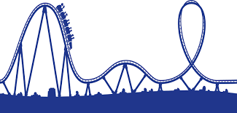

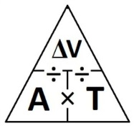
- The formula for acceleration is shown below:
$acceleration=a= \frac{ }{ }=\frac{(vf-vi)}{t}$

Math Skills
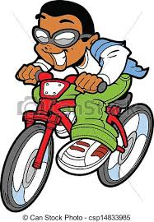 | Little Timmy rides his bicycle north to school each day. His initial velocity is 0 m/s. After 2 minutes, his velocity is 6 m/s. Find the kid’s acceleration in meters per second squared (m/s²). Remember to include direction.
Given:
Unknown:
Perform conversions:

Use the equation for speed:
$$a=\frac{(vf-vi)}{t}=$$
Write the velocity by including direction:

$$a=\frac{(vf-vi)}{t}$$
- A roller coaster’s initial velocity at the top of the hill is 10 m/s. Two seconds later it reaches the bottom of the hill with a final velocity of 26m/s. What is the acceleration of the coaster?
- A roller coaster is moving initially at 25 m/s at the bottom of a hill. Three seconds later it reaches the top of the hill finally moving at 10 m/s. What was the acceleration of the coaster?
- A swimmer speeds up from initial velocity of 1.1 m/s to 1.3 m/s during the last 20 seconds of the race. What is the acceleration of the swimmer?
- A cars velocity changes from 0 m/s to 30 m/s in 10 seconds. Calculate acceleration.
- A satellite’s initial velocity is 10,000 m/s. After 60 seconds it is going 5,000 m/s. What is the acceleration?
- A car goes from a stop to 30 m/s in 25 seconds. What is the acceleration?
- If a speeding train hits the brakes and it takes the train 39 seconds to go from initially 54.8 m/s to final velocity of 12 m/s. What is the acceleration?

8. A roller coaster car rapidly picks up speed as it rolls down a slope. As it starts down the slope, its speed is initially 4 m/s. But 3 seconds later, at the bottom of the slope, its speed is finally 22 m/s. What is its acceleration?
9. A cyclist accelerates from 0 m/s to 8 m/s in 3 seconds. What is his acceleration?

10. A car advertisement states that a certain car can accelerate from rest to 70 m/s in 7 seconds. Find the car’s average acceleration.
11. A lizard accelerates from 2 m/s to 10 m/s in 4 seconds. What is the lizard’s average acceleration?
12. A runner covers the last straight stretch of a race in 4 s. During that time, he speeds up from 5 m/s to 9 m/s. What is the runner’s acceleration in this part of the race?
13. You are traveling in a car that is moving at a velocity of 20 m/s. Suddenly, a car 10 meters in front of you slams on its brakes. At that moment, you also slam on your brakes and slow to 5 m/s. Calculate the acceleration if it took 2 seconds to slow your car down.
13. A ball is dropped from the top of a building. After 2 seconds, its velocity is measured to be 19.6 m/s. Calculate the acceleration for the dropped ball.

