FPS – Unit 4 Review – Chapter 14-15

Name____________________________ Period__________

Conceptual Understanding
- Define work in scientific terms, and give the formula. What is it measured in?
- Define power in scientific terms, and give the formula. How is it measured?
- Define kinetic & potential energy in scientific terms, and give the formula(s). What is the unit?
- Which factors affect gravitational potential energy? Kinetic energy?
- How can machines make work easier for you?
- What is mechanical energy? Give the formula and an example.
- What is chemical energy? Explain and give an example.
- What is thermal energy? Explain and give an example.
- What is electrical energy? Explain and give an example.
- What is electromagnetic energy? Explain and give an example.
- What is nuclear energy? Explain and give an example.
- Define the law of conservation of energy.
- List the energy types from your foldable and give examples.

Applying Concepts
- What energy conversions occur when lighting a match? Use complete sentences, and be sure to mention AT LEAST 4 different types of energies.
- Recall the watermelon experiment. Using the list of words provided and in complete sentences, describe in terms of energy what occurred and why.
a. elastic c. converted
b. potential energy d. force
e. surface area f. overcome
g. propagated
- How many watts are in one horsepower? Convert 12,000 watts to horsepower.
- How can you increase power?
- How does gravitational potential energy change on the moon? Why?

Graphical and Mathematical Problems
The triangles below may help you with work and power. You will have all necessary formulas on the test, but NOT units or how to rearrange them. Write the formulas in the space provided to complete the math problems below.

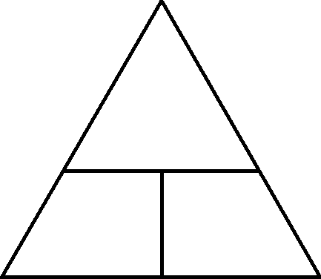

- What is the force necessary for an engine to do 632 J of work over 30 meters?
- What is the work done over 10 meters with 1200 N of force?
- Cheryl is a young girl climbing up a 2 m flight of 10 stairs. She is essentially “carrying” herself up the stairs, and her weight is 60 N. What is the work done per step?
- How long does it take Cheryl to cut the grass if her lawnmower has 40 watts of power and she needs to do 6,000 J of work?
- How powerful is a horse that can do 50,000 J of work in 40 s? How much horsepower does it have? (1 hp = 746 watts)
- Cheryl and her friend James are playing in a parking lot while their parents shop. James wants to push Cheryl (who weighs 50N) in a shopping cart which weighs 18 N across the parking lot. The parking lot is 42 meters long, and it takes James 3 minutes to push her all the way across. Showing all your work, how powerful is James? (Hint: find work done first, and make sure all units are correct before solving.)
- If a plane is traveling at 150 m/s and has a mass of 8930 kg, how much energy does it have?
- A 49 kg skateboarder is sitting at the top of a 34 m ramp ON THE MOON (g=1.6 m/s²). How much energy does she have?
- A 59 kg skateboarder is sitting at the top of a 34 m ramp ON THE EARTH (g=9.8 m/s²). How much energy does she have?
- A system has 10 J of kinetic energy and 11 J of potential energy. What is the mechanical energy?
- A system has 100 J of mechanical energy and 21 J of potential energy. What is the kinetic energy?
- On Earth (g=9.8 m/s²), a machine with a mass of 15 kg has 100 J of mechanical energy and 25 J of kinetic energy. How high up is the object? (Hint: solve for the potential energy first.)
- The bonus questions will come from the Understanding Car Crash video notes. Please review those notes/videos to prepare for the bonus!

