FPS – Work and Power Notes

Name____________________________ Period__________

I can…
Define work and power.
Calculate work and power.
Identify examples of work and power.

Work and Power Notes
Bellwork: Write down three examples of what you think work is.

- What is work?
- In science, the definition of work is:
- Both the _____________ and the ___________ of the object are in the
______________ direction.

- Work or not?
- a teacher lecturing her class YES / NO
- A mouse pushing a piece of cheese with its nose across the floor YES / NO

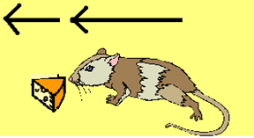
- The mouse is using a ____________________ to move the cheese a _______________________; both _
____________________________________
____________________________________
_____________________________________.
- 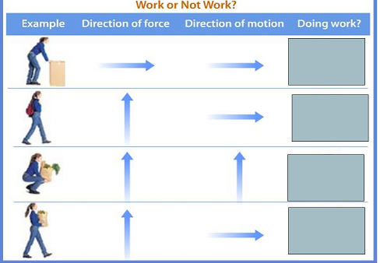
- What’s work?
- A scientist delivers a speech to an audience of his peers.
YES / NO
- A body builder lifts 350 pouds above his head.
YES / NO
- A mother carries her baby from room to room.
YES / NO
- A father pushes a baby in a carriage.
YES / NO
- A woman carries a 50 kg grocery bag to her car.
YES / NO
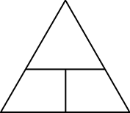
- Formula for work

- The unit of force is ___________________________________.
- The unit of distance is ____________________________.
- The unit of work is _________________________________.
- A Newton-meter is equal to one joule.
- Unit for work is a _____________________________.
- The Joule
- Named after British Physicist __________________________________________________.

- Let’s practice calculating work. (W = F x d)
- If a man pushes a concrete block 10 meters with a force of 20 N, how much work has he done?

- Power
-What do you think makes something powerful?
_________________________________________________
_________________________________________________
- Measure of how ___________________ work is done.
- Amount of ______________ per unit of ______________________.
- Formula:

- The unit of power is the _____________________________.
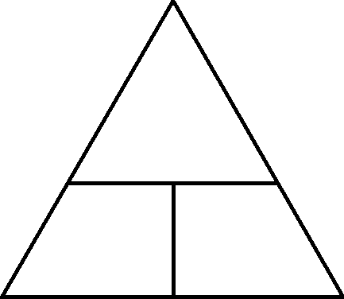
- Unit named after Scottish inventor ______________________________________.
- Invented the _______________________________.
- Watts – used to measure ______________________ and other small appliances. Your electric bill is measured in _______________.

Practice Problems
Let’s calculate work and power. Use these formulas:
$$Work\left(Joules\right)=Force \left(Newtons\right)×distance (meters)$$
$$Power\left(Watt\right)=\frac{Work \left(Joules\right)}{time (s)}$$
- Solve for work if a box is pulled with a force of 500N for 5 m.
- Solve for distance is if 2 Joules of work is done with 4 N of force.
- Solve for power if 90 Joules of work is done in 20 seconds.

- Solve for time if 20 Joules of work is done with a power of 6 watts.
Try the others on your own, and get a teacher’s initial to check them! Don’t forget UNITS!
- Amy uses 20N of force to push a lawn mower 10 meters. How much work does she do? | Teacher Initial
- Joe balances a coin using 1 N of force and lifting it 0.20 meters. How much work does he do?

- Frank does 2400 J of work by climbing stairs. If he does this for 100m, how much force does he apply?
- How much power do you need to do if you pull a sled if you want to use 60 J of work in 5 seconds? | Teacher Initial
- How much work does an elephant do while moving a wagon 20 meters with 200 N of force?

- If it takes you 5 seconds to do 1000 J of work, what is your power output?

- A 200N mountain climber scales a 100 meter cliff. How much work is done?

- A small motor does 4000j of work in 20 seconds. What is the power of the motor?

- A woman runs a race using a power output of 500 W and applying 6000 J of work. How long does it take her?

- What is the distance you go if you apply 600 N of force and 1200 J of work?

- What is the work you do if you use a power of 10 W and it takes you 10 seconds?

- You do 1400 J of work in 90 seconds. What is your power?

- How much time does it take you to do 1400 J of work if you have a power output of 80 watts?

- Solve for power if 90 Joules of work is done in 20 seconds.

- Solve for work if a box is pulled with a force of 500N for 5 m.

- A dog jumps 1 meter by applying 10 N. What is the dog’s work?

Text in your response to the survey on the board when you are done!

