FPS – Waves notes 2

Name____________________________ Period__________

I can…
Define properties of waves.
Identify the various behaviors of waves.

Thermal Energy - Notes
BELLWORK – List the properties of a wave.  ______________________________________  ______________________________________ | 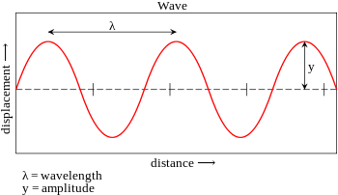
- Waves are _____________________ and they transport ___________________________. The energy of a wave is _______________________ to its _________________________.
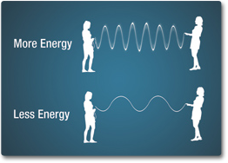
- The ________________ is a measure of the wave ________________.
SOUND: amplitude corresponds to _______________________.
LIGHT: amplitude corresponds to _______________________.
- What is the wavelength? __________________________________________________________________________________________________________________________
- Frequency – _______________________ passing a stationary point ________________________________.
- Period (T) – length of _____________ for one ___________________.
If a source is oscillating with a period of 0.1 seconds
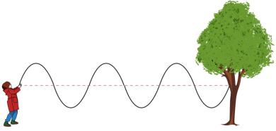
- Wave Speed (v) – depends on the _________________________ and ______________________.
Formula:
One end of a rope is vibrated to produce a wave with a wavelength of 0.25 meters. The frequency of the wave is 3 Hertz. What is the speed of the wave?

- The relationship between frequency and wavelength:
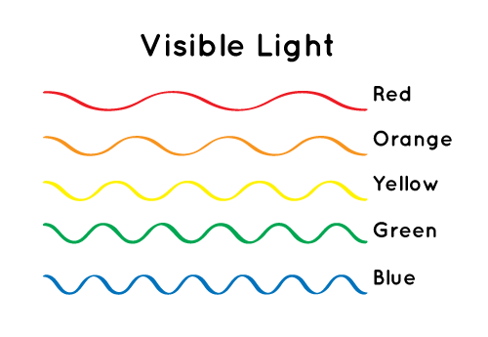

- Behavior of Waves
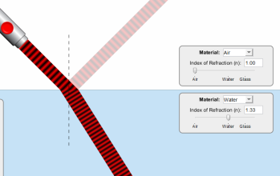
-____________________________ occurs when a wave ___________________ a surface that it cannot pass through. A reflected wave has a smaller _______________________ than the original wave because some _____________ is lost during reflection.
-_______________ occurs when a wave ____________________________ and ______________ of the wave moves more ______________________ than the other side.
-______________occurs when a wave
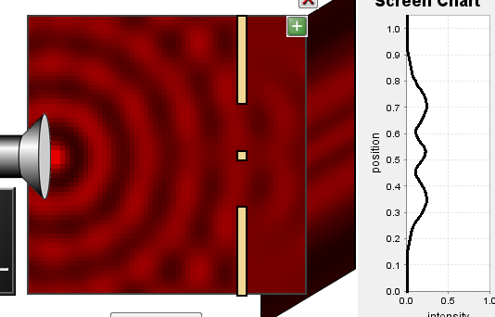
___________________________ or _______________________________.
-________________________ occurs when two or more
waves _____________________________.
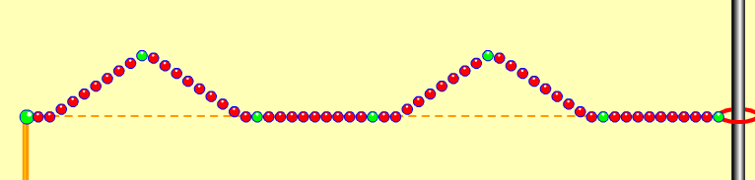
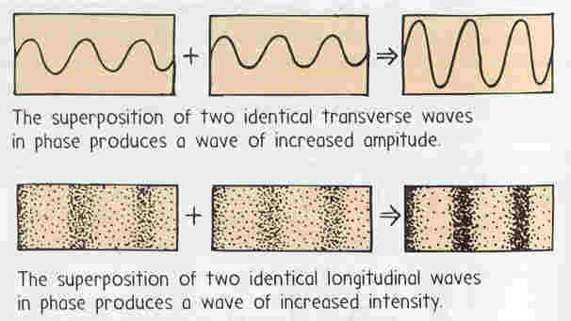
- Constructive interference -

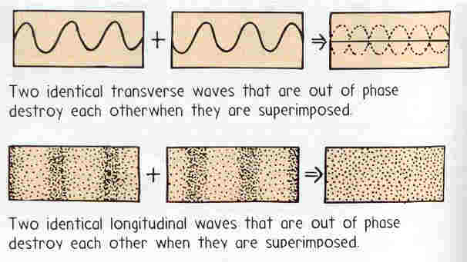
- Destructive Interference -

