FPS – Waves Introduction Worksheet

Name____________________________ Period__________

I can…
Relate the properties of a wave.

Waves
- The illustration below shows a series of transverse waves. Label each part.
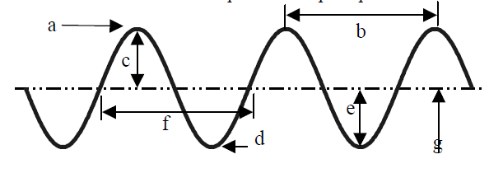

- Waves carry __________________ from one place to another.
- The highest point on a transverse wave is the ___________________ while the lowest part is the ________________________.
- The __________________________ is the height of the wave.
- The distance from one crest to the next is the ___________________.

- Compare the following waves.
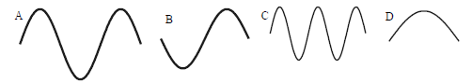
- Which has the biggest amplitude?_____
- Which has the shortest wavelength? _____
- Which of the above has the longest wavelength? _____
- Which has the greatest frequency? ______
- Draw a wave with a very high frequency and low amplitude.

- Draw a wave with a low frequency and high amplitude.

