FPS – Waves Intro Virtual Lab

Name____________________________ Period__________

I can…
Define the parts of a wave.
Relate the properties of a wave.

- Go to http://phet.colorado.edu/
- On the left, click “Simulations”
- Scroll all the way to the bottom and click the LAST simulation – “Waves on a String”
- Click the play button
Laws of Motion lab
- Let’s make some observations to start. What are some things we can change?
- Select “Manual”. 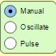
Then, click and drag the wrench. Describe how these waves look. (Ex.: is it smooth? Are they fast?)
- Select “Oscillate”. 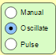 Describe these waves and how they are different from “Manual”.
- Select “Pulse”. 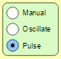Then, click the green button. 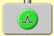
What happens? How is this different from manual or oscillate?
- Select “Oscillate” and “No End”. 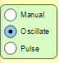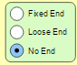
What are the 4 properties you can change at the bottom of the screen?
- Change the “Amplitude” however you like. What happens?
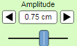
- Change the “Amplitude” however you like. What happens?
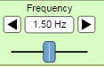
- What are the three types of “ends” you can have?

- Select “Fixed End.” 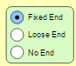
List any differences you notice.
- Select “No End.” 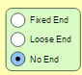
List any differences you notice.
- Look around the room. Are there any objects with fixed ends? List them.
- Now let’s play with amplitude and frequency. What is the current amplitude and frequency? Include UNITS.
- Press “pause” and sketch the wave.
- Change the Amplitude to 1.25 cm and press play. Press pause again, and sketch the wave.
- Change the Frequency to 0.80 Hz (or close) and press play. Press pause again, and sketch the wave.
- Compare your sketches from #14 and #15. In COMPLETE sentences, describe how the wave changed.

- In COMPLETE sentences, describe what happens to a wave if frequency goes UP. (Use the simulation to help you if you need to!)
The Quiz!
Go to http://join.quizizz.com and enter the game pin on the board to get started! Record your nickname and score below.

