FPS – Velocity and Acceleration in Graphs

Name____________________________ Period__________

I can…
Interpret graphs to solve for velocity and acceleration.
Identify velocity and acceleration given various graphs.

Bellwork
On the graph to the left, show an object travelling at a constant speed.

Graphs
- Distance vs. Time graphs
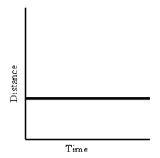

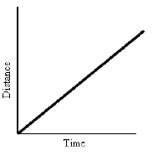

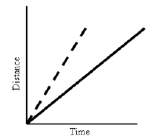

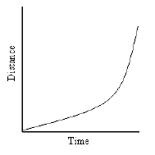
- Velocity vs. Time graphs
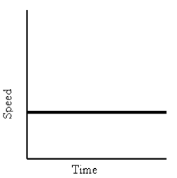
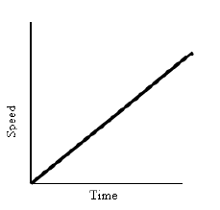 |  |  | 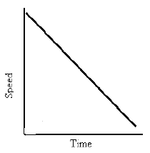
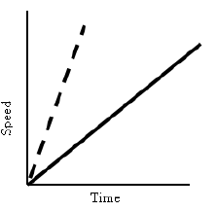
Practice!
The distance-time graphs below represent the motion of a car. Match the descriptions
with the graphs. Explain your answers.
Descriptions:
1. The car is stopped.
2. The car is traveling at a constant speed.
3. The speed of the car is decreasing.
4. The car is coming back.
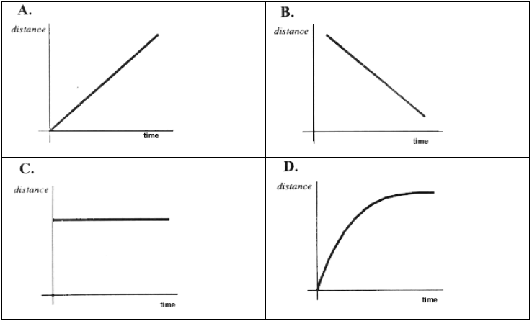
Graph A matches description _____ because __________________________________.
Graph B matches description _____ because __________________________________.
Graph C matches description _____ because __________________________________.
Graph D matches description _____ because __________________________________.
The speed-time graphs below represent the motion of a car. Match the descriptions
with the graphs. Explain your answers.
Descriptions:
5. The car is stopped.
6. The car is traveling at a constant speed.
7. The car is accelerating.
8. The car is slowing down.
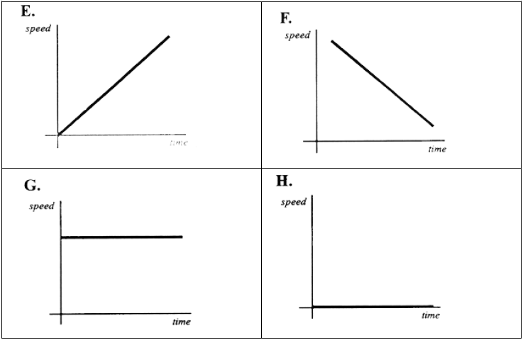
Graph E matches description _____ because __________________________________.
Graph F matches description _____ because __________________________________.
Graph G matches description _____ because __________________________________.
Graph H matches description _____ because __________________________________.
The graph below shows how the speed of a bus changes during part of a journey.
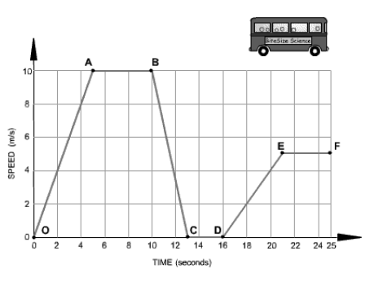
Choose the correct words from the following list to describe the motion during each
segment of the journey to fill in the blanks.
• accelerating
• decelerating
• constant speed
• at rest
Segment 0-A The bus is ______________________________. Its speed changes
from 0 to 10 m/s in 5 seconds.
Segment A-B The bus is moving at a __________________________________of 10
m/s for 5 seconds.
Segment B-C The bus is ____________________________________. It is slowing
down from 10 m/s to rest in 3 seconds.
Segment C-D The bus is ____________________________________________. It has
stopped.
Segment D-E The bus is ________________________________________________.
It is gradually increasing in speed.

