FPS – Unit 4 problems review lab

Name____________________________ Period__________

Pre- lab Practice
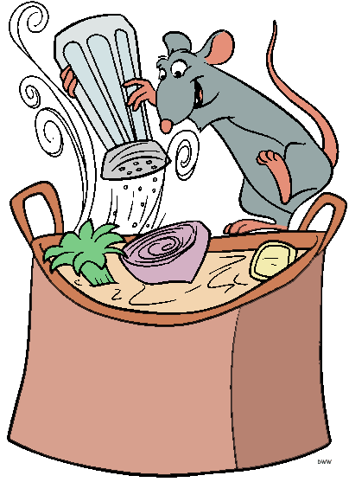
1. Remy the rat needs to cook Thanksgiving dinner for his little rat family. He’s pretty small at a mass of only 0.145 kg. He hoists himself up on the counter to begin cooking. His climb is about 0.98 meters. What is the work that Remy does to get on the counter?
- Remy decides to use a 600 W powerful mixer to get the stuffing done more quickly. In order to mix the stuffing perfectly, he needs to do about 2110 J of work. How long will it take Remy to do this work?

- What can Remy do to increase the power if he needs to do the SAME amount of work?

- As they eat, they are perched up 0.98 meters on the counter. Remy has a mass of 0.145 kg. He sits motionless watching his family enjoy the meal. What is his potential energy?
- Remy’s little rat family needs a total of 7000 J of kinetic energy so they can move around for the day. If a rat moves at a speed of 0.5 m/s, what is the mass of his entire family? What is the mass of each rat if he has a total of 11 members (including himself)?

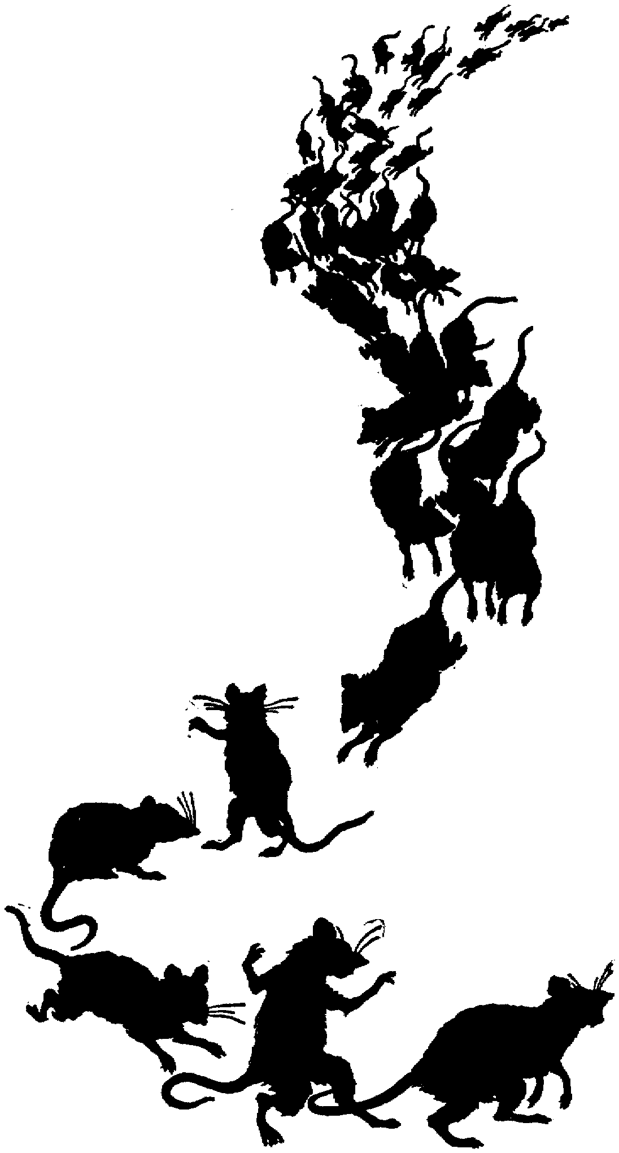
- Remy’s family hears a noise in the kitchen and as a little rat-mass, they run squeaking to safety to a
hole in the wall. Using their mass from #5, and their energy increasing to 10,110 J what is their
velocity as they run?

I can…
Define and explain work, power, and energy forms.
Calculate work , power, and energy forms using coding strategies in word problems.
Analyze conversions of energy in a scenario.
Work with your partner(s) to answer the following questions.
Staion One: Work and Power
- List the items at the station.

- Select an item you will be using. _______________________________
- Using this item find the force with a spring scale ______________ N
- Select a person from your group to lift the item 0.5 meters. Decide how many reps they will do. Group member:_______________________ # of reps:_____________________
- How long does it take them? Time:_____________________
- Find the TOTAL work done. (Hint… there is a reason you recorded # of reps…)
- Find the power.
- How could they increase their power?
Teacher initials

Station Two: Energy
- Select an object at this station. Find the mass of the object using the scale and record it.
Mass: ___________________g

Mass/1000 = Mass in kilograms
Mass in kilograms: _________________________kg

- Set it on the lab table. What is the height? _______________m (Make sure it is in meters…)
- What is the gravitational potential energy?

- Raise the item higher. Record the height at which you hold the item. ____________________m
- What is the gravitational potential energy now?
- Now drop the item on the floor from this height. Using this formula, find the velocity when it hits the ground.
$$v=\sqrt{2gh}$$

- Using the velocity, what is the kinetic energy?  Teacher initials | - Does GPE_{i}=KE_{f}? Why do you think so or why not? BE SPECIFIC.

Station Three: Graphing Energy
- Take the bouncy ball labelled A and bounce it. Describe the motion in complete sentences.

- Like the skateboarder lab (image shown below to remind you…) graph the energy of the first bounce (from the peak, halfway down, and to the lab table).
Peak of Path
On Lab Table
Halfway Down
- Is all the energy conserved directly from kinetic to potential? Why or why not?

