FPS – Types of Chemical Reactions & Balancing

Name____________________________ Period__________
Bellwork
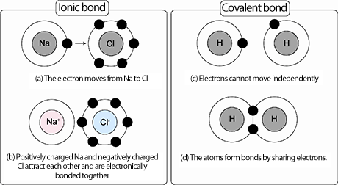 | - What do remember about ionic bonds?  - What do you remember about covalent bonds?
- Remember that atoms bond together to have a full ________________ shell, and to create _________ substances.
- This chapter, we will be looking at ________________ ______________, which is a process that one or more substances ______________ to form new substances.
- There are many different types of chemical reactions. Can you give an example of two? Write the examples below.
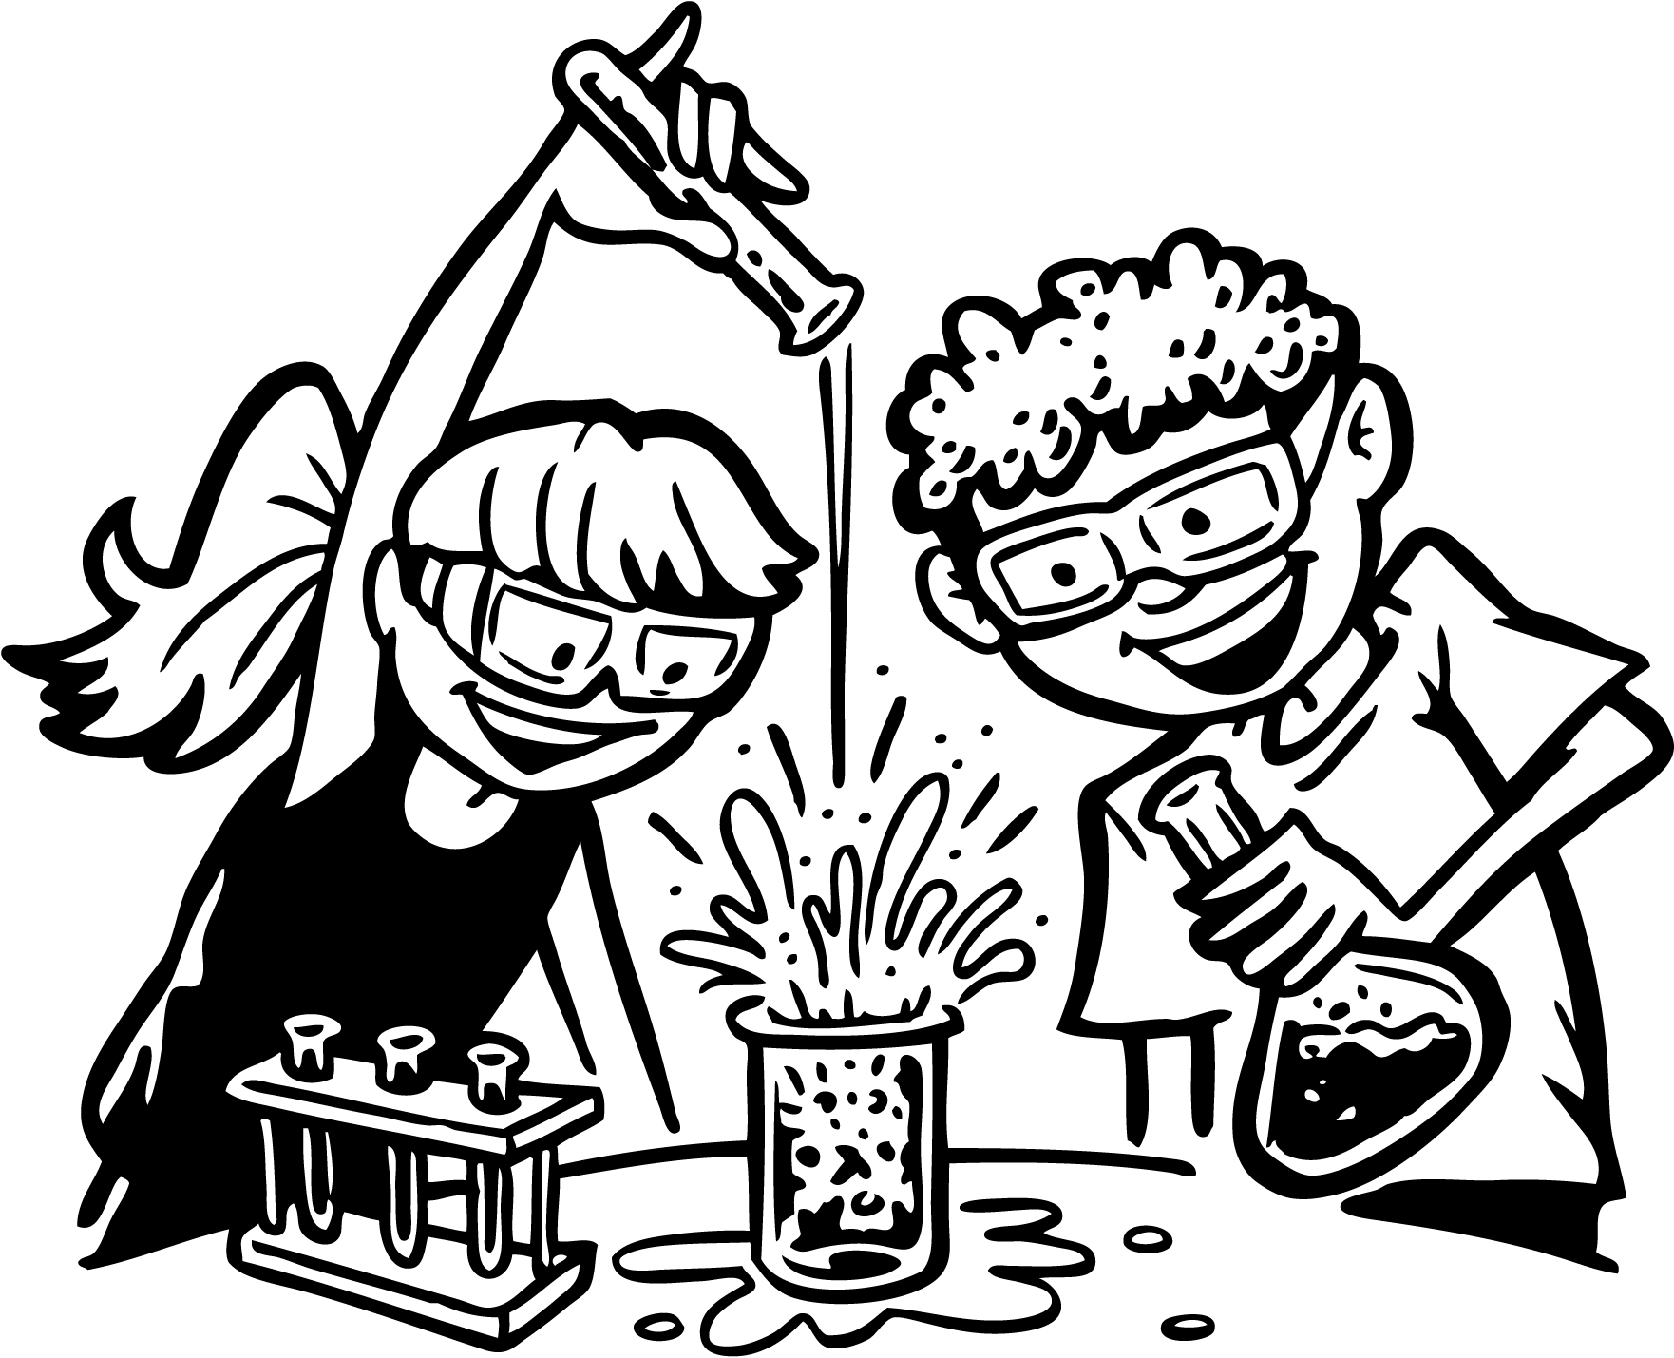 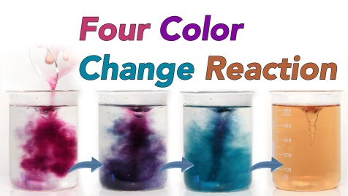
- What are some things that show a chemical reaction is happening?
_______________________ _______________________
_______________________ _______________________
- What do we call a solid formation in a chemical reaction? _________________
- What are the parts in a chemical reaction?
∙ _______________________________ are the __________________ substances in the chemical reaction.
∙ _______________________________ are the substances that are _____________________ in the chemical reaction.
- Label the formula for a reaction.
2 Al + 3Br₂ 2AlBr₃
- What are the five types of reactions?
_______________________ __________________________________
_______________________ __________________________________
________________________
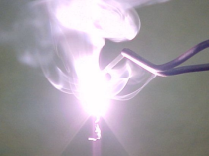
- A _____________________________ reaction occurs when two substances, usually two _________________________ combine and form one _________________________.
A + B AB
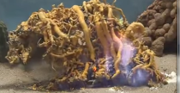
- A ____________________________ reaction occurs when one _______________ compound is broken down into __________ __________________ substances.
AB A + B
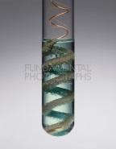
- A ___________________________________ reaction occurs when one __________________takes the place of another in a _________________________.
A + BC B + AC
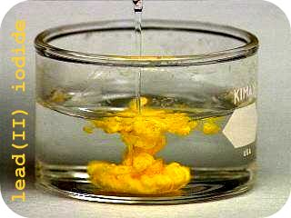
- A ________________________________ reaction occurs when ions ___________________ places in _______ _____________________.
AB + CD AD + CB
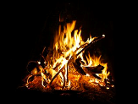
- A _______________________________ reaction is a reaction of a carbon-based compound with ____________________.
C₃H₈ + O₂ → CO₂ + H₂O
- What do you think the Law of Conservation of Mass states?
- We need to ___________________________ chemical equations to satisfy the Law of Conservation of Mass. When balancing, we cannot change the ___________________ but we can add _______________________.
- When balancing, count the atoms on the ____________________ side and the ____________________ side. If they are not equal, add coefficients. These coefficients ____________________ the entire chemical formula. Then recount until reactants and products are equal.
Let’s do an example together.
______CH₄ + _____O₂ ______H₂O + _______CO₂
Count the atoms:
Now, add coefficients to make them equal!!
Reactants: C ___ H____ O ____
Products: C ___ H____ O ____

Vocabulary list – Use your book or notes to complete the list.
- Chemical reaction
- Precipitate
- Chemical formula
- Chemical equation
- Reactant
- Product
- Law of conservation of mass
- Synthesis reaction
- Decomposition reaction
- Single-displacement reaction
- Double-displacement reaction
- Exothermic reaction
- Endothermic reaction
- Law of conservation of energy
- Catalyst

