FPS – Static Electricity Notes

Name____________________________ Period__________

Static Electricity - Notes
- What is static electricity?
__________________________________________________________________
__________________________________________________________________
- There are two kinds of charges. Rub the plastic ruler and tear off a small piece of paper. What happens?
____________________________________________________________________
____________________________________________________________________
____________________________________________________________________
____________________________________________________________________
- Where do charges come from?
____________________________________________________________________
____________________________________________________________________
Label the atom.
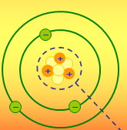
-If electrons = protons
-If electrons > protons
-If electrons < protons
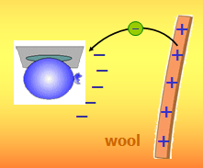
- Where do charges come from?
Rubbing materials does __________ ___________ electric charges. It just
_____________________ electrons from one material to another.
When a balloon rubs a piece of wool…
- Insulators and Conductors
Insulators
Conductors

- Induction
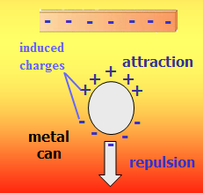
- Static Discharge
____________________________________________________________
____________________________________________________________
- Mini Quiz
- A balloon has a negative change when rubbed by a woollen cloth. If the balloon can attract some paper scraps, which of the following cannot be the charge of the paper scraps?
- A balloon has a negative change when rubbed by a woollen cloth. During rubbing, what have been transferred between the woollen cloth and the balloon?
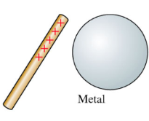
- How does a positively charged rod attract a neutral object?
When a + charged rod is put near neutral object, ______________ is induced on the side of the object near the rod and _____________ is induced on the side away from the rod. The rod can attract the netural object because _________ between rod and – induced charge > the ________ between rod and + induced charge.

- Lightning
Sketch the diagram below.
- Law of Charges
