

**FPS –Static Electricity Lab**

Name____________________________ Period__________

|  |
| --- |
| I can… |
| *Describe and explain scenarios demonstrating static electricity.*  *Analyze authentic examples of static electricity by identifying charge transfer, electric forces, and induction.*  *Construct diagrams of charge transfer and induction.* |

|  |
| --- |
| Pre-Lab |
| 1. What is the difference between charging my friction and charging by induction? 2. How can an object be charged by induction? Explain using a specific example. 3. Label the following diagram with **charges, charge transfer,** and **induced charges.** |

|  |
| --- |
|  |
| You will be working partly with a virtual simulation and with real objects, including water. Please be careful with the laptops near the water!!! |

|  |
| --- |
| ***Static Electricity lab*** |
| *Materials*  -laptop -balloons -string -aluminum can -salt and pepper -paper scraps -wool/cloth - fur -comb -tape |
| *Part 1- Procedure*   1. Take one blown up balloon and rub it against your hair or to the wool. 2. Put the balloon near the scraps of paper. 3. Removing all the scraps of paper, rub the balloon on the wool/hair again. 4. Put the balloon near the salt and pepper mixture. 5. Record results (Part 1 Analysis A-E) 6. Go to <http://shakerscience.weebly.com> Foundations 🡪 Quarter 2 🡪 Week 7 🡪 Wednesday and click the link to the “Balloon Lab” and rub the balloon on the sweater. 7. Record new results and correct any diagrams (Part 1 Analysis F-G) |
| *Part 1- Analysis Questions*   1. What process were you doing when you rub the balloon on cloth/hair? What is happening involving ***electrons***? 2. What process is happening when you put the balloon near the scraps of paper? What is happening involving the ***electrons***? 3. Why do you think you needed to rub the balloon again in step 3? 4. What happens when you put the balloon near the salt and pepper mixture and WHY do you think this happens? 5. Sketch the balloon and the salt and pepper mixture in the box below, and predict what the charges would be on all of the objects. 6. On the virtual simulation, rub the balloons on the sweater. What happens to the charges? 7. Label your original sketch with any corrections from the virtual simulation. |
| *Part 2- Procedure*   1. Take two blown up balloons and rub them against your hair or to the wool. 2. Put the balloons near one another. Record your answers to the analysis questions A-C. 3. Do the same on the virtual simulation by clicking “Add Balloon”. Record your answers to questions D-E. 4. Put the balloon near the aluminum can. Record your answers to question F. |
| *Part 2- Analysis Questions*   1. What happens to the balloons and what charge do they carry? 2. How did the balloons get that charge? 3. Why did the electric force between the balloons behave the way it did? (Hint… think about the Law of Charges) 4. Describe how the balloons became charged in the virtual simulation. 5. Sketch a diagram in the box below to show the charges, charge transfers, AND electric forces. 6. What happens when you put a balloon near the can? Explain using a labelled diagram or complete sentences. |
| *Part 3- Procedure*   1. Take the comb and run it through hair or charge by friction with wool/fur. (Note: Hair WITHOUT product works the best). 2. Turn on the faucet so that the stream is about 0.5 cm wide (it should be very thin). 3. Hold the comb near the water without touching it. Record your answers to Part 3 - Analysis. |
| *Part 3- Analysis Questions*   1. What happens to the water? WHY do you think this happens? 2. What might this tell you about water molecules? (Hint: think about subatomic particles) 3. Can you think of other ways to exert an electric force on the water? |
| *Part 4- Procedure*  Using any of the items provided, design a new experiment to demonstrate static electricity. The only requirement is that you use **more than one** provided item and that you demonstrate some type of **change in motion by charging an object**. Write your procedure below, and describe your results (either in complete sentences or a labelled diagram).  Material used:________________________________________________            *Results:* |

Complete the exit ticket, tear it off, and turn into the tray!



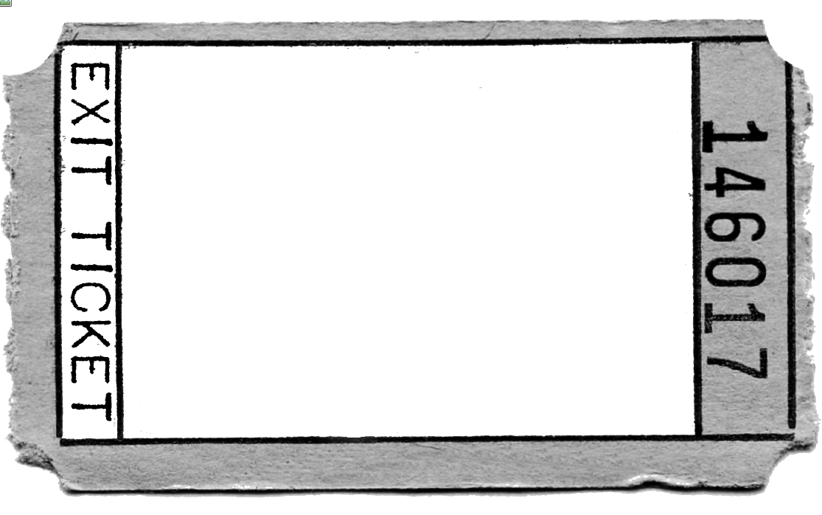

1. **What is the main difference between charging by friction and charging by induction?**
2. **Based on what you’ve seen today, what do you think are some ways static electricity could be useful?**
3. **What are some way static electricity could be harmful?**

**Name:________________**