FPS – Sound and Light notes

Name____________________________ Period__________

I can…
Distinguish between various regions of the electromagnetic spectrum.

Sound and Light - Notes
- Doppler Effect
- Change in _____________________ of a wave due to the ________________________ between _____________ and ______________.
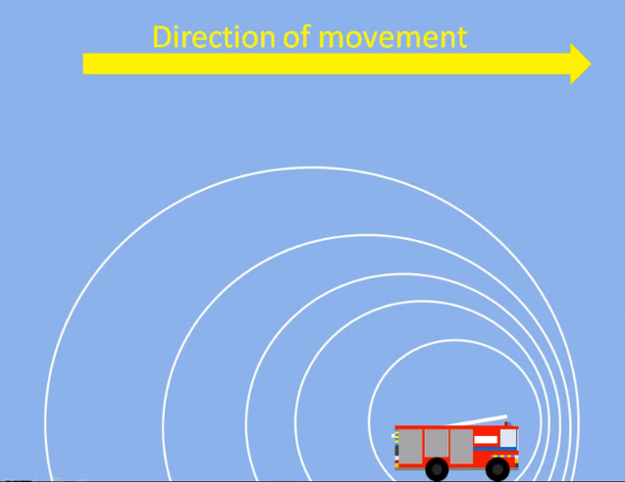
- Doppler Effect for Light Waves
A light wave change in frequency is noticed as a change in “_________________”.
The Doppler Effect will cause shifts in frequency causing color shifts as:
Object coming toward = ______________ Shift
Object moving away = _____________ Shift
- Electromagnetic Spectrum
- The electromagnetic spectrum spreads from _______________ rays to _______________, ____________________ rays, ___________________________ waves and even longer ___________________________ waves, ________________________, to _______________ waves which can measure longer than a mountain range.
- Electromagnetic waves are similar to ocean waves in that both are _________________ waves. They transmit energy.
- EM waves have _________________ and ______________________ properties.
- Unlike ocean waves, EM waves travel through the ________________ of space at the constant speed of light.
- Many EM waves are tiny and measured in billionths of a meter, or _________________________.
- Adding energy increases the _______________________ of the wave.
- Our eyes are tuned to a specific region of the EM spectrum and can detect energy with wavelengths of ______________ to ____________ nanometers, the visible light region of the spectrum.
(0:17-3:57)
- Fill in the electromagnetic spectrum:
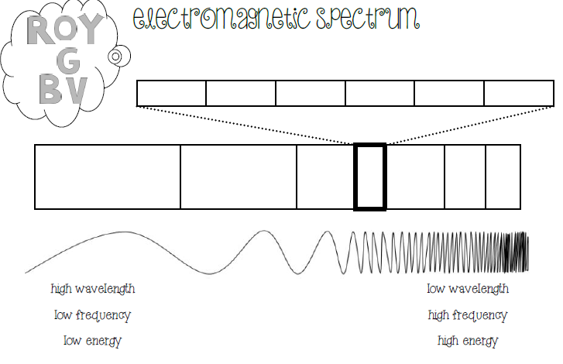
List examples of each:

- Speed of Light

- speed of light = wavelength x frequency
- c = 300,000,000 m/s
A radio station broadcasts a radio wave with a wavelength of 3.0 meters. What is the frequency of the wave?
Given: Rearrange: Plug & Solve:

- Practice Questions
- A radio station is emitting radio waves at a frequency of 4,291,845 Hz. What is the wavelength of the radio wave?
- The lunchroom microwaves have a wavelength of about 0.68 m. What is the frequency of the emissions?
- An infrared lamp emits rays at a frequency of 1,188,000,000 Hz. What is the wavelength?

