FPS – Sound and Electromagnetic Spectrum

Name____________________________ Period__________

Sound and Light notes
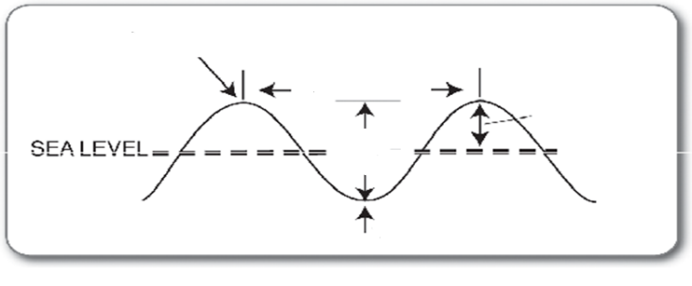
- Label the parameters of the wave.
- What are 3 types of mechanical waves?
- Sound waves – As intensity (___________________) is increased, then the sound gets ________________________.
As frequency is increased, then the sound gets __________________________.
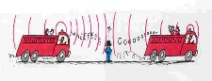
- Doppler effect -- ____________________________________________________________________
___________________________________________________________________________________
We notice this as a change in pitch.
- Doppler effect for light waves -- ____________________________________________________________________
___________________________________________________________________________________
We notice this as a change in color.
Object coming towards us = ______________shift
Object moving away from us = ______________shift

Sound and Light notes continued
8. Speed of Light – speed at which electromagnetic waves travel through a vacuum
c= 300,000,000 m/s
Formula:

A radio station broadcasts a radio wave with a wavelength of 3.0 meters. What is the frequency of the wave?

9. Practice Questions

- A radio station is emitting radio waves at a frequency of 4,291,845 Hz. What is the wavelength of the radio wave?

- The lunchroom microwaves have a wavelength of about 0.68 m. What is the frequency of the emissions?

- An infrared lamp emits rays at a frequency of 1,188,000,000 Hz. What is the wavelength?

Work with your partner(s) to answer the following questions.

