**FPS – Semester 2 FINAL Review**

Name____________________________ Period__________

1. Define the following terms:
   1. Matter
   2. Atom
   3. Pure substance
   4. Element
   5. Compound
   6. Mixture
   7. Homogeneous
   8. Heterogeneous
   9. Solutions
   10. Suspensions
   11. Colloids
   12. Malleable
   13. Brittle
   14. Ductile
   15. Conductivity
   16. Melting point
   17. Boiling point
   18. Density
   19. Viscosity
   20. Flammability
   21. Reactivity
   22. Boyle’s Law
   23. Charles’s Law
   24. Immiscible
   25. Temperature
   26. Pressure
2. List several physical properties.

1. How can physical properties be used?
2. List two chemical properties.
3. What is the different between a physical change and a chemical change?
4. Give 3 examples of a physical change and justify.
5. Give 3 examples of indications of a chemical change. Then, give 3 examples of different chemical changes.
6. What is the Tyndall effect and which mixture does it identify?
7. Give several examples of elements.
8. Give several examples of compound.
9. How is a homogeneous mixture different from a heterogeneous mixture? Give several examples of both.

1. List and describe the three states of matter and SKETCH the particle arrangements.
2. Which state of matter has the highest energy and why?
3. List 5 phase changes and define them.
4. Why is a phase change a physical change?
5. Give 2 examples that demonstrate Boyle’s Law.
6. Give 2 examples that demonstrate Charles’s law.
7. Explain why bicycle tires seem more flat in the winter.
8. Explain why a can of soda explodes if left in the sun.
9. Steel has a density of 7.8 g/cm3. What is the mass of the block of steel with a volume of 600cm3? (Hint 1mL = 1cm3)
10. A substance has a mass of 360 g and a volume of 7.5 cm3. What is its density?
11. Identify each of the following as a compound or an element.
    1. Cl _________________________
    2. CH4 _______________________
    3. Co ________________________
    4. CO2_______________________
12. State the laws that fit with the following graphs.

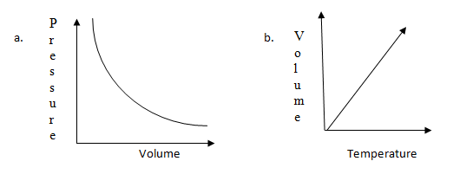

1. ***History of Atomic Theory***
2. Summarize the following people’s discoveries and ideas. Dates/drawings will not be required on the test.
   1. Democritus
   2. *Atomos*
   3. Dalton
   4. Thomson
   5. Plum-pudding model
   6. Rutherford
   7. Gold-foil experiment
   8. Bohr’s model
   9. Electron-cloud model
3. What were some differences between Dalton and Democritus’s ideas?

1. Who described the Billiard ball model? Why was it called such?
2. Rutherford, who was Thomson’s student, refuted the plum-pudding model. Describe how his experiment did this.
3. How is Bohr’s model different than previous models?
4. How is the electron-cloud model different than previous models?
5. What were Dalton’s three parts of his Atomic Theory of matter?
6. According to Bohr’s model of the atom, where are the electrons? What can happen for them to change location?
7. ***The Periodic Table & Atomic Structure***
8. How is the modern periodic table of element arranged?
9. Assuming the atom is neutral, what does the atomic number tell you?
10. Label the following periodic table square for argon.  
    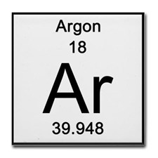
11. What is a period? What does a period on the periodic table indicate about an element?
12. What is a group/family? What does a group/family on the periodic table indicate about an element?
13. What do valence electrons indicate about an element?
14. What is an ion? What do we call a positive and negative ion?
15. What is the octet rule? What are the exceptions?
16. What does the mass number tell you? What are isotopes?

1. In nuclear notation, write the isotopes magnesium-24, magnesium-25, and magnesium-26.
2. What is the average atomic mass of Boron if it exists as 19.90% 10B and 80.10% 11B?
3. Magnesium has three naturally occurring isotopes. 78.70% of Magnesium atoms exist as   
   Magnesium-24, 10.03% exist as Magnesium-25 and 11.17% exist as Magnesium-26. What is the average atomic mass of Magnesium?
4. ***Element Categories***
5. Describe properties of the alkali metals and give an example.
6. Describe properties of the alkaline-earth metals and give an example.
7. Describe properties of the transition metals and give an example.
8. Describe properties of the metalloids and give an example.
9. Describe properties of the halogens and give an example.
10. Describe properties of the noble gases and give an example.
11. What happens to metallic properties as you move from left to right on the periodic table?
12. What happens to reactivity as you down a group on the periodic table?
13. WHY do the alkali metals become more reactive down the group?
14. WHY do the halogens become more reactive up the group?
15. ***Electron Configurations***
16. What are the 4 types of orbitals? How many electrons can each of them hold?

1. Write the complete electron configuration for the following elements:
   1. Potassium _______________________
   2. Lithium __________________
   3. Aluminum _________________
   4. Carbon ______________
   5. Nitrogen ________________________
   6. Argon _______________________
2. Write the electron configurations for the following ***ions.*** Remember, if an ion is positive, it has lost electrons. If an ion is negative, it has gained electrons.
   1. Be2+ __________________
   2. B3+ _________________________
   3. Cl1= ________________________
   4. O2= ____________________
3. Identify the errors in the following electron configurations. If there is no error, write “none”.
   1. 1s22s32p2 _________________________
   2. 1s22s22p63s24s1 _______________________
   3. 1s22s22p83s1 _____________________
4. Write the electron configuration for the following orbital diagrams. Then, identify the element.
   1. http://home.miracosta.edu/dlr/images/sulfur.gif
   2. 
   3. 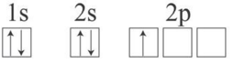

Use your periodic table and the images and formulas below as reference.

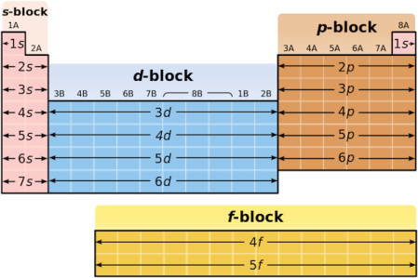 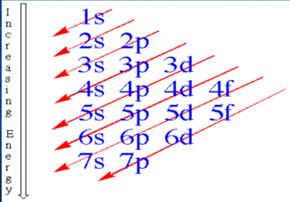 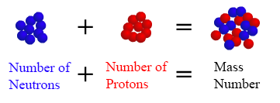 $$average atomic mass=\left(isotope mass x \frac{\%}{100}\right)+\left(isotope mass x \frac{\%}{100}\right)+…$$

1. ***Bonding***
2. Define the following bonding types and give examples of the compounds that are bonded in that way.
   1. Ionic
      1. Examples:
   2. Covalent
      1. Examples:
   3. Metallic
      1. Examples:
3. What are some identifying properties of ionic bonds? How are the ions arranged?

1. What are some identifying properties of covalent bonds? How are the units different from ions?
2. What are some identifying properties of metallic bonds? How are the electron interactions unique?
3. Describe the differences in valence electron behavior for each of the 3 bonding types.
4. What is the octet rule? How do atoms satisfy the octet rule?
5. How are the bonds in H2O different from the bonds in Li2O?
6. On the periodic table below, identify the ***3 main categories*** of elements. Then, label the charges for each column.  
   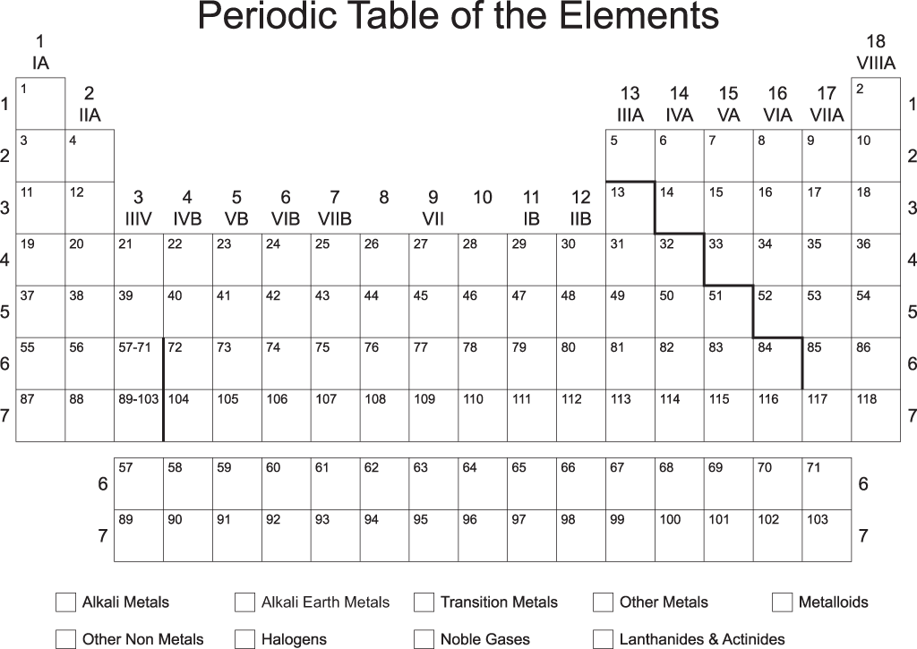
7. ***Lewis Dot Structures and Bonding***
8. What is depicted in a Lewis dot structure?
9. Draw the Lewis dot structures for the following elements:
   1. Carbon
   2. Aluminum
   3. Lithium
   4. Helium
   5. Argon
   6. Phosphorus
   7. Silicon
   8. Oxygen
   9. Fluorine
10. Draw the Lewis dot structures for the following compounds. Remember, subscripts tell you the number of atoms present per unit.
    1. H2O
    2. CH4
    3. LiCl
    4. Na2S
    5. O2
11. Write the chemical formulas for the ionic compounds containing the following elements. Refer to #8 for charges to use the crossing method.
    1. Na and O
    2. Ca and Cl
    3. Mg and N
    4. Cs and F

***C. Naming Binary Compounds***

1. What are the differences in naming covalent and ionic compounds?
2. When do you NOT use a prefix for a covalent compound?
3. Fill in the prefix table below.

|  |  |
| --- | --- |
| ***Prefix*** | ***Number*** |
|  | 1 |
|  | 2 |
|  | 3 |
|  | 4 |
|  | 5 |
|  | 6 |
|  | 7 |
|  | 8 |
|  | 9 |
|  | 10 |

1. Name the following ***ionic*** compounds:
   1. NaCl
   2. MgF2
   3. AlCl3
   4. BeO
2. From the following names, write the chemical formula for the ionic compounds. Write the ions first, then use the crossing method.
   1. Sodium oxide
   2. Magnesium oxide
   3. Barium fluoride
   4. Lithium bromide
3. Write the names for the following ***covalent*** compounds.
   1. CO
   2. CO2
   3. N2H4
   4. SO4
   5. N3O5
   6. CS6
4. Write the formula for the following names.
   1. trisilicon tetrafluoride
   2. carbon trioxide
   3. dichlorine heptoxide
   4. tetracarbon decasulfide
   5. boron hexachloride
   6. dihydrogen dioxide
5. Below is a mixed set of chemical compounds. Ionic and covalent are both present. Name or give the chemical formula.
   1. CaO h. Potassium bromide
   2. H2O2  i. Nitrogen trioxide
   3. Carbon dioxide j. NO
   4. Magnesium oxide k. SF6
   5. PCl3 l. Strontium nitride
   6. NH2  m. Diphosphorus pentoxide
   7. Dinitrogen monoxide
6. ***Definitions***
7. Define and give the “formulaic” pattern for each type of reaction.
   1. Synthesis
   2. Decomposition

* 1. Single displacement
  2. Double displacement
  3. Combustion

1. Describe many observations that can be made when a chemical reaction is occurring.

1. What is a precipitate?
2. List AND define the parts of a chemical equation.
3. Define the Law of conservation of mass.
4. Why do we balance chemical equations?
5. Why can’t you change the subscripts of a chemical equation when balancing?
6. What is the rate of a reaction? What are the four factors that can affect the rate of a reaction?
7. What is activation energy?
8. Why doesn’t a reaction last forever and constantly increase its rate?
9. How and WHY does temperature affect the rate of reaction?
10. How and WHY does increased surface area speed up the rate of reaction?
11. How and WHY does increased concentration speed up the rate of reaction?
12. How and WHY does using a catalyst speed up the rate of reaction?
13. What three catalysts are commonly used in industry? Why are catalysts important?
14. What is the difference between endothermic and exothermic reactions? How can we tell in the lab?
15. What is a molar mass?
16. How do you calculate a molar mass? Explain using NaCl as an example.
17. ***Application  
    Balance and write the type of reaction.***

Type of reaction:

1. Na + O2 🡪 Na2O
2. SF6 🡪 S + F2
3. Al + CuSO4 🡪 Cu + Al2 (SO4)3
4. Pb(NO3)2 + NH4Cl 🡪 PbCl2 + NH4NO3
5. Al2O3 + H2O 🡪 Al(OH)3
6. Fe2O3 🡪 Fe + O2
7. Zn + SnCl2 🡪 Sn + ZnCl2
8. Cu(NO3)2 + Na2S 🡪 CuS + NaNO3
9. Al(OH)3 + H2SO4 🡪 Al2(SO4)3 + H2O
10. C2H4 + O2 🡪 CO2 + H2O
11. Ag + S 🡪 Ag2S
12. Al + Fe2O3 🡪 Fe + Al2O3
13. HgO 🡪 Hg + O2
14. KCl + AgNO3 🡪 AgCl + KNO3
15. Al2(SO4) 3 + Ca(OH) 2 🡪 CaSO4 + Al(OH)3
16. Al + Fe2O3 🡪 Fe + Al2O3
17. Al + O2 🡪 Al2O3
18. C3H8 + O2 🡪 CO2 + H2O
19. Draw an energy diagram for an endothermic reaction.
20. Draw an energy diagram for an exothermic reaction.  
      
      
      
    117. *Calculate the molar masses of the following chemicals:*

1) Cl2

2) KOH

3) BeCl2

4) FeCl3

5) BF3

6) CCl2F2

7) Mg(OH)2

8) UF6

9) SO2

10) H3PO4

11) (NH4)2SO4

12) CH3COOH

13) Pb(NO3)2

14) Ga2(SO3)3

1. Describe **homogeneous mixtures**.
2. Describe **heterogeneous mixtures**.
3. Describe the parts of solutions (solute and solvent).
4. Describe a suspension.
5. Describe a colloid.
6. Describe the terms unsaturated, saturated, and supersaturated.
7. In the lab, how did we *supersaturate* a solution?
8. Describe the ways we can alter solubility.
9. What is a base? Give some examples.
10. Give the properties of a base.
11. What is an acid? Give some examples.
12. Give the properties of an acid.
13. Which ion does a base give off? An acid?
14. Why do acids and bases conduct electricity?
15. When an acid and a base come together, what happens?
16. What colors do Acids and Bases turn litmus paper?
17. Describe the pH scale. What does it measure? Where do acids fall? Bases?
18. Using what you know about the litmus colors produced by acids and bases, fill in the table below.

|  |  |  |  |
| --- | --- | --- | --- |
| ***Red litmus paper*** | ***Blue litmus paper*** | ***pH*** | ***Acid, base, or neutral?*** |
| Red | Blue |  | neutral |
|  | Blue | 11 |  |
|  |  | 4 | acid |
|  | Blue | 8.5 | base |
|  | Blue | 7 |  |
| Red |  | 1 |  |

1. If you test two fruits, and find that the lemons has a pH of 3 and the apple a pH of 5, which is the **stronger** acid? Why?
2. What is the nucleus of an atom composed of?
3. What is a strong force?
4. How are the strong forces between a large nucleus and a small nucleus different?
5. Why does nuclear decay happen?
6. What two things are released during nuclear decay?
7. What is an isotope?
8. Give an example of isotopes of Carbon.
9. What does it mean when a nucleus is unstable or *radioactive?*
10. In what elements did Marie Curie discover radioactivity?
11. What is an alpha particle?
12. What is a beta particle?
13. What is a gamma ray?
14. How are alpha and beta particles different?
15. How are gamma rays different from alpha and beta particles?
16. Which is the most dangerous radiation AND why?
17. Complete the following equations.

a) 🡪 + _______

b) 🡪 + _________

c) 🡪 + _________

d) 🡪 + _____

e) ________ 🡪 +

1. List the type of radiation shown in a-e in question one.
2. _____________________ d) _____________________
3. _____________________ e) _____________________
4. _____________________



1. Describe the size of stars in the H-R diagram (in comparison with the sun) in the upper right portion:

much larger somewhat larger the same size somewhat smaller much smaller

1. Describe the color of the stars in the upper right portion of the H-R diagram.

redder about the same color bluer

1. Describe the color of the stars in the upper left portion of the H-R diagram.

redder about the same color bluer

1. Where in the H-R diagram would you find a star with a greater temperature than the sun?

left right above below

1. Where in the H-R diagram would you find a star with a greater luminosity than the sun?

left right above below

1. What is the classification of the Sun?_____________________________
2. What is the classification of Rigel?________________________________
3. Name a star that is a Blue.___________________
4. Which star is most similar to the sun?_______________
5. What is the temperature of the sun?_______________
6. Name a star that is hotter than the sun but smaller in size __________________
7. Name a star that is cooler than the sun but larger in size___________________
8. How much dimmer than the sun is Eridani B? _________________________
9. How would you characterize the stars that are both very bright and cooler?

blue giants red giants white dwarfs red dwarfs sun-like

1. Name on star that is brighter than Aldebaran_____________________
2. What is the hottest main sequence star?___________________________