**FPS –Review Part 2**

Name____________________________ Period__________

1. What are the scales of temperature? What are the formulas to convert among them?
2. Define Heat and temperature.

1. What does temperature measure? Be specific.
2. How does the speed of particles affect the temperature?
3. How does a thermometer measure the kinetic energy?

1. What is the formula for calculating *heat*? Write the formula, define each variable, and give its appropriate unit(s).

1. What are the 3 types of thermal energy transfer? Define them.

1. What is an example of each type of heat transfer?

1. Define the 3 laws of thermodynamics.

1. Explain what coats, jackets, curtains and other **insulators** do.

|  |  |  |
| --- | --- | --- |
| **Fahrenheit** | **Celsius** | **Kelvin** |
| **220 °F** |  |  |
|  | **25°C** |  |
|  |  | **266 K** |
|  | **39°C** |  |
| **70°F** |  |  |

1. See the heating curve for water below. Fill in the missing terms.

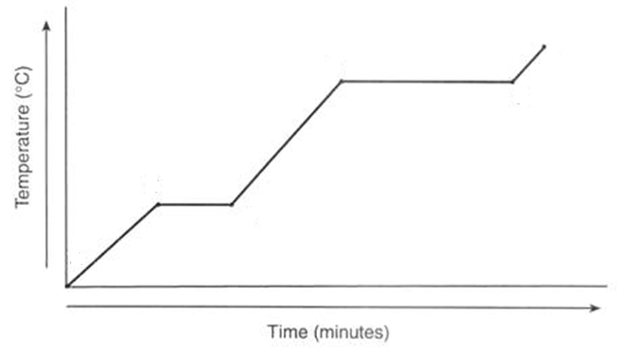

**100°C -**

**0°C -**

1. Describe the types of energy occurring on the roller coaster in the image below, and indicated at each point the relative values of the energies.



1. How can a machine make work easier for you?
2. What energy conversions occur when lighting a match?
3. 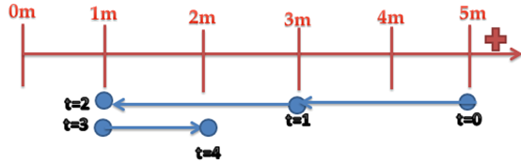Describe the motion for the motion map.
4. In the position vs. time graph, describe the motion.

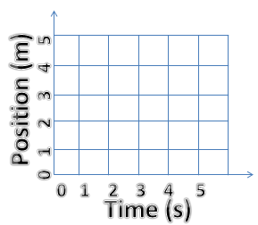

1. 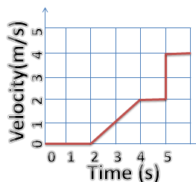In the velocity vs. time graph, when is the object NOT moving?
2. 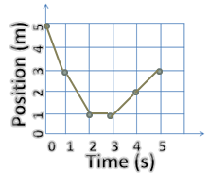For the velocity vs. time graph, describe the motion.
3. Create a motion map from the position vs. time graph.

**0m**

**5m**

1. Define work in scientific terms, and give the formula. What is it measured in?
2. Define power in scientific terms, and give the formula. How is it measured?
3. Define kinetic & potential energy in scientific terms, and give the formula(s). What is the unit?
4. Which factors affect gravitational potential energy? Kinetic energy?
5. How can machines make work easier for you?
6. What is mechanical energy? Give the formula and an example.
7. What is chemical energy? Explain and give an example.
8. What is thermal energy? Explain and give an example.
9. What is electrical energy? Explain and give an example.
10. What is electromagnetic energy? Explain and give an example.
11. What is nuclear energy? Explain and give an example.
12. Define the law of conservation of energy.
13. What is the force necessary for an engine to do 632 J of work over 30 meters?
14. What is the work done over 10 meters with 1200 N of force?
15. Cheryl is a young girl climbing up a 2 m flight of 10 stairs. She is essentially “carrying” herself up the stairs, and her weight is 60 N. What is the work done ***per step***?
16. How long does it take Cheryl to cut the grass if her lawnmower has 40 watts of power and she needs to do 6,000 J of work?
17. If a plane is traveling at 150 m/s and has a mass of 8930 kg, how much energy does it have?
18. A 49 kg skateboarder is sitting at the top of a 34 m ramp ON THE MOON (g=1.6 m/s2). How much energy does she have?
19. A 59 kg skateboarder is sitting at the top of a 34 m ramp ON THE EARTH (g=9.8 m/s2). How much energy does she have?
20. A system has 10 J of kinetic energy and 11 J of potential energy. What is the mechanical energy?