FPS – Reactions Chapter 7 - Unit 11 Review

Name____________________________ Period__________

- Definiti
- Define and give the “formulaic” pattern for each type of reaction.
  - Synthesis
  - Decomposition

  - Single displacement
  - Double displacement
  - Combustion

- Describe many observations that can be made when a chemical reaction is occurring.

- What is a precipitate?
- List AND define the parts of a chemical equation.
- Define the Law of conservation of mass.
- Why do we balance chemical equations?
- Why can’t you change the subscripts of a chemical equation when balancing?
- What is the rate of a reaction? What are the four factors that can affect the rate of a reaction?
- What is activation energy?
- Why doesn’t a reaction last forever and constantly increase its rate?
- How and WHY does temperature affect the rate of reaction?
- How and WHY does increased surface area speed up the rate of reaction?
- How and WHY does increased concentration speed up the rate of reaction?
- How and WHY does using a catalyst speed up the rate of reaction?
- What three catalysts are commonly used in industry? Why are catalysts important?
- What is the difference between endothermic and exothermic reactions? How can we tell in the lab?

- Application
- How is the modern periodic table of element arranged?
Increasing atomic number
- Assuming the atom is neutral, what does the atomic number tell you?
Number of protons and (if neutral) number of electrons
- Label the following periodic table square for argon.
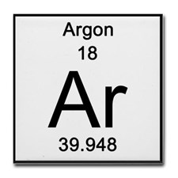
element name
atomic number
chemical symbol
average atomic mass
- What is a period? What does a period on the periodic table indicate about an element?
Period = row (horizontal). Tells us the number of energy levels
- What is a group/family? What does a group/family on the periodic table indicate about an element?
Group/family = column (vertical) Tells the number of valence electrons (excluding the transition metals)
- What do valence electrons indicate about an element?
Properties, Reactivity and Bonding
- What is an ion? What do we call a positive and negative ion?
An ion is an atom that has become charged due to a transfer of valence electrons to become stable. Cation = “paws”itive and anion= negative
- What is the octet rule? What are the exceptions?
States that in order to most stable, an atom must have 8 valence electrons in the outer shell. Hydrogen and helium are the exceptions.
- What does the mass number tell you? What are isotopes?
Mass number = number of protons + number of neutrons
Isotopes are atoms that has differing number of neutrons
- In nuclear notation, write the isotopes magnesium-24, magnesium-25, and magnesium-26.
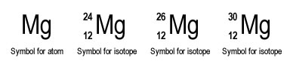
25
- What is the average atomic mass of Boron if it exists as 19.90% ¹⁰B and 80.10% ¹¹B?
$$average atomic mass=\left(isotope mass x \frac{\%}{100}\right)+\left(isotope mass x \frac{\%}{100}\right)+… \\ average atomic mass=\left(10 x \frac{19.90\%}{100}\right)+\left(11 x \frac{80.10\%}{100}\right)$$= 10.801 amu
- Magnesium has three naturally occurring isotopes. 78.70% of Magnesium atoms exist as
Magnesium-24, 10.03% exist as Magnesium-25 and 11.17% exist as Magnesium-26. What is the average atomic mass of Magnesium?
$$average atomic mass=\left(24 x \frac{78.70\%}{100}\right)+\left(25 x \frac{10.03\%}{100}\right)+\left(26 x \frac{11.17\%}{100}\right)$$=24.2997 amu
- Element Categories

- Describe properties of the alkali metals and give an example.
Highly reactive, do not occur in nature, one valence electron. Ex: Li, Na
- Describe properties of the alkaline-earth metals and give an example.
Highly reactive, do not occur in nature, two valence electrons Ex: Mg, Be
- Describe properties of the transition metals and give an example.
Metallic properties (shiny, malleable) and do not fill inner shells consistently Ex: Cu, Co, Au
- Describe properties of the metalloids and give an example.
Sometimes conductive at very high temperatures due to some metallic and nonmetallic properties. Ex: Si, B
- Describe properties of the halogens and give an example.
Highly reactive, vary in state of matter, 7 valence electrons Ex: F, Cl
- Describe properties of the noble gases and give an example.
Very unreactive (inert) with 8 valence electrons. all in gaseous states Ex.: Ne, He, Ar
- What happens to metallic properties as you move from left to right on the periodic table?
Become less metallic, solid to gas
- What happens to reactivity as you down a group on the periodic table?
Typically increases
- WHY do the alkali metals become more reactive down the group?
valence electron becomes further away due to atomic size and can be lost easier
- WHY do the halogens become more reactive up the group?
Valence electrons are closer to the nucleus at the top of the group (ex.: F) and therefore can more easily and violently attract another electron. Due to the Law of Charges

- Electron Configurations

- What are the 4 types of orbitals? How many electrons can each of them hold?
s, p, d, f
s = 2 electrons p= with 3 at each energy level, holds 6 electrons total
d= with 5 at each energy level, holds 10 electrons total
f= with 7 at each energy level, holds 14 electrons total
- Write the complete electron configuration for the following elements:
  - Potassium ____1s²2s²2p⁶3s²3p⁶4s¹
  - Lithium _______1s²2s¹____________
  - Aluminum ______1s²2s²2p⁶3s²3p¹___________
  - Carbon _______1s²2s²2p²_______
  - Nitrogen _______1s²2s²2p³____________
  - Argon _________1s²2s²2p⁶3s²3p⁶_____________
- Write the electron configurations for the following ions. Remember, if an ion is positive, it has lost electrons. If an ion is negative, it has gained electrons.
  - Be²⁺ _______1s²__________
  - B³⁺ _______1s²__________________
  - Cl¹⁼ ______1s²2s²2p⁶3s²3p⁶_______________
  - O²⁼ ____1s²2s²2p⁶___________________
- Identify the errors in the following electron configurations. If there is no error, write “none”.
  - 1s²2s³2p² _s orbitals only hold 2 electrons
  - 1s²2s²2p⁶3s²4s¹ ______3p orbitals were not filled before moving to 4s________
  - 1s²2s²2p⁸3s¹ _______p orbitals only hold 6 electrons_________
- Write the electron configuration for the following orbital diagrams. Then, identify the element.
  - 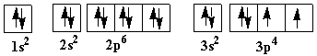1s²2s²2p⁶3s²3p⁴ ; sulfur
  - 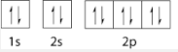1s²2s²2p⁶ ; neon
  - 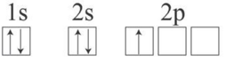1s²2s²2p¹ ; Boron

Use your periodic table and the images and formulas below as reference.

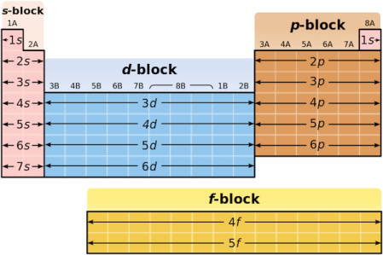 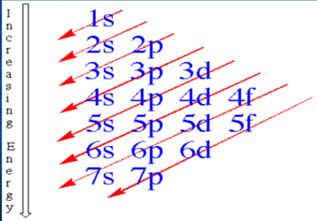 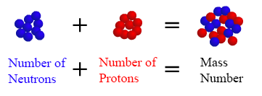
$$average atomic mass=\left(isotope mass x \frac{\%}{100}\right)+\left(isotope mass x \frac{\%}{100}\right)+…$$

