FPS – Nuclear reactions notes

Name____________________________ Period__________
Bellwork
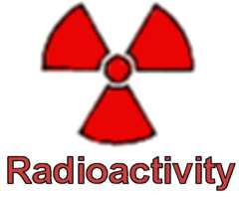 |  | - Listen to the nuclear decay song, then list 3 things you remember from the song.
- Nuclear Radioactivity:
  - _____________________ composed of protons and neutrons
  - Strong force causes ________________ and ______________________ to be attracted.
  - Powerful only when protons and neutrons are closely _______________ together.
  - Large nucleus is held ___________ tightly than a small nucleus
- Nuclear decay happens when the ___________ _____________ is not large enough to hold the ______________________together.
a. The nucleus gives off ______________ and __________________ until they transform into a different isotope or another element.
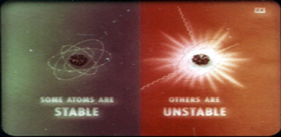
- Isotopes atoms with the same number of _____________________, but different number of ____________________.
Examples: Carbon-14 6 protons, 8 neutrons
Carbon-12 6 protons, 6 neutrons
- An atom’s ________________________ will depend on the ratio of protons to neutrons in the nucleus.
  - A nucleus with either too many or too few neutrons compared to protons is _______________________________________
- POP QUIZ: Explain why nuclear decay occurs.
_______________________________________________________________
_______________________________________________________________
_______________________________________________________________
_______________________________________________________________
- History:
  - 1896 – Henri Becquerel discovered radioactivity with __________________
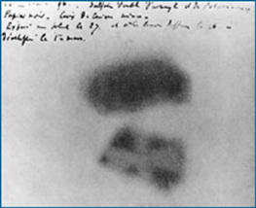
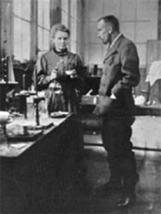
  - 1898 – Marie & Pierre Curie discovered radioactivity with ___________________ and __________________

- Nuclear radiation – Particles and energy released from ____________________ nucleus. There are 3 types:
  - ______________ particles
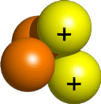
  - ______________ particles
  - ______________ rays
- Alpha(α) particles consist of 2 _________________ and 2 _______________ with a charge of +2. They do not travel far due to _______________ and _______________. Though they are the least penetrating form of radiation, they can cause serious _____________________.

- Beta (β) particles ________________ emitted during the decay of a neutron into a proton in an _____________________ nucleus. They can travel farther and faster than alpha particles because beta particles are so ________________.

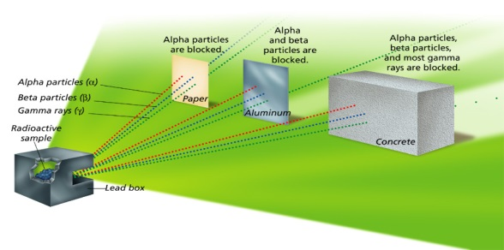
- Gamma(γ) Rays high energy electromagnetic radiation emitted by a nucleus during radioactive decay. They have no _____________ and no ______________. These rays can penetrate matter deeply, even _____________________.

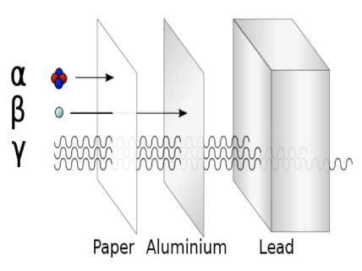 | - What are the three types of decay we talked about?
- When an atom is radioactive, it is… _____________________________________
_____________________________________________________________________
- Half-life of radioactive isotopes
a. The length of ________________ it takes _________________ of the atoms of a sample of radioactive isotopes to ___________________.
b. Varies from fractions of a __________________ to billions of ______________
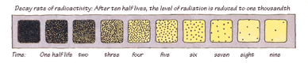
c. Do you remember plutonium’s half-life? _________________
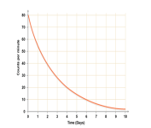
- How can we use radioactive half-lives?
Can be used to determine the ___________ of old objects, such as
_________________________________________________________.
- Rate of Nuclear decay
-There are two ways to determine the rate of decay.
-The first is by the rate at which the ___________ of the radioactive isotope ____________.
-The second is by the rate at which the _______________ (alpha and beta) is _______________. (counts per minute on the ______________ counter)
-The half life is a constant that is dependent on the isotope, time of half life does not change over time.
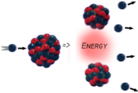
- Nuclear fission the process of ___________________________ a nucleus into two nuclei with smaller masses
- Chain reaction an ongoing series of _____________________ reactions
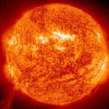
- Nuclear fusion two nuclei with low masses are _________________________ to form ONE larger _________________
a. Can only happen when nuclei are moving _______________
b. Temperature must be as high as the temperature of a ___________

- Nuclear Notation

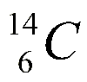

- Nuclear reactions
When an atom undergoes nuclear decay it alters the makeup of the nucleus.
It will ______________ to a new element.
________ particle decrease atomic number by __ and the mass number by __
U
238
92
⎯⎯→
Th
234
90
He
4
2
+
________ particles increase the atomic number by ____ and cause the mass number to remain unchanged.
I
131
53
Xe
131
54
⎯⎯→
+
e
0
−1
Complete the review questions and nuclear reactions alone or with a partner!
- What is the nucleus of an atom composed of?
- What is a strong force?
- How are the strong forces between a large nucleus and a small nucleus different?
- Why does nuclear decay happen?
- What two things are released during nuclear decay?
- What is an isotope?
- Give an example of isotopes of Carbon.
- What does it mean when a nucleus is unstable or radioactive?
- In what elements did Marie Curie discover radioactivity?
- What is an alpha particle?
- What is a beta particle?
- What is a gamma ray?
- How are alpha and beta particles different?
- How are gamma rays different from alpha and beta particles?
- Which is the most dangerous radiation AND why?

