FPS – Unit 2 – Motion Review

Name____________________________ Period__________

Conceptual Understanding
- What is a frame of reference and why do we need one?
- Give an example of a scenario in which you need a frame of reference.
- What is a distance?
- What is the SI Unit for distance?____________
- What is a displacement?
- How is displacement different from distance?
- What is a vector quantity?
- What is speed? What are the SI units for speed?
- How is instantaneous speed different from average speed?
- What information does a speedometer provide you with?
- What is velocity? How is it different from speed?
- What is acceleration? What are the ways an object can accelerate?
- What is the value of acceleration due to gravity?___________________
- Define the ways each of the examples are accelerating: a horse on a carousel, a roller coaster, a plane taking off, a car stopping in a straight line.
- Define constant acceleration. How does it look on a speed-time graph? How does it look on a distance-time graph?
- Write the equation for velocity and for acceleration.
Applying Concepts
- List three vector quantities.
- You are riding in a car that is travelling 50 km/hr east. You look out the window and see a train that seems to also be moving in a similar velocity, and you see some trees as well. Which is the better frame of reference for your car’s motion? Why?
- You walk 1.2 miles east to school from home. Then, you walk 0.2 east to the store, and then return home. What is your total displacement? Distance?
- You walk 1.4 miles east to the store, and then walk 0.2 miles west to school. What is your total displacement? Distance?
- You walk 3 blocks west and then 6 blocks north to get to school, but your crow flies in a straight line to school and beats you there. (a) Explain who is travelling the total distance or total displacement in this scenario and (b) draw and calculate both distance and displacement.

- On a distance-time graph, (a)what would the curve describing constant speed look like? (b)Constant positive acceleration? Describe and sketch them.
- On a speed-time graph, (a)what would the line describing constant speed look like? (b)Constant acceleration? Describe and sketch them.
- If an object is traveling with constant velocity, what do you know about the acceleration?

Calculations and Graphing
- A dragonfly flies from 1m to 2m in 1 sec. Then she zooms to 5m in 1 sec and stays there for 2 sec. Then, she flies to 3m in another second and stays there for anotehr second. From the description, create a position v. time graph.
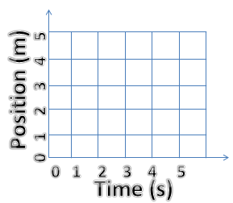
What times is it moving the fastest?_______________
What times is it stationary?___________________

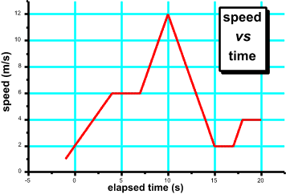
- Describe what is occurring in the following speed-time graph from 0-20 seconds.
- Referring to the same graph, is the object ever stationary? How do you know?
- During which approximate time intervals is the object accelerating?
Speed | Time
12 m/s | 0 s
9 m/s | 2 s
6 m/s | 4 s
3 m/s | 6 s
0 m/s | 8 s
- Plot a speed-time graph with the following data. Don’t forget all appropriate labels and TITLES!
a. What is the slope of the line?
b. Is the acceleration positive, negative, or zero? How do you know?
c. Is the object ever at constant velocity? Constant acceleration?
d. Describe a story for the motion depicted on the graph.

- Describe the motion of the bus from point O all the way to point F. Use complete sentences.

