FPS – Motion Notes

Name____________________________ Period__________

I can…
define and apply concepts of motion.
apply knowledge of distance and displacement.
Solve and interpret speed problems.

Bellwork
What is a frame of reference?

Motion Notes
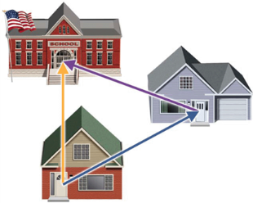
- _______________________ is an object’s change in position relative to a _______________________.
- _______________________ is the change in the position of an object.
- _______________ measures the total path taken.
- Displacement is the change of an object’s position. Displacement must always indicate _____________________.

- A squirrel walks from a tree (position 0m) to his hole in a log (position 1m) in 1 sec. He hears a dog coming and springs to another tree (position 5m). The squirrel remains stationary in the tree for 2 sec until he feels safe enough to sprint back to the log (1m) in 1 sec.
5m
0m

- Let’s make a position vs. time graph.
A squirrel walks from a tree
(position 0 m) to his hole in a log
(position 1 m) in 1 sec. He hears
a dog coming and sprints to
another tree (position 5 m).
The squirrel remains in the tree
for 3 sec until he feels safe enough
to return to the log (1 m) in 1 sec.
Position (m)
Time (s)
0 1 2 3 4 5
0 1 2 3 4 5

- ___________________ is the distance traveled divided by the _________________ interval
during which the motion occurred. Speed describes how _________ an object moves.
- Speed measurements involve _________________ and _______________.
- The SI units for speed are _________________ per _____________ (m/s).
- When an object covers equal distances in equal amount of time, it is moving at a ______________________________.
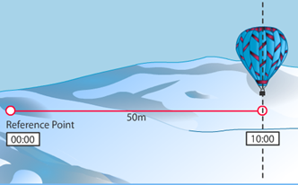 |  | $$Speed= \frac{distance}{time}= \frac{ }{ }= \frac{ }{ }$$
- Speed can be studied with graphs and equations.  Speed can be determined from a distance-time graph. When an object’s motion is graphed by plotting _______________ on the y-axis and __________ on the x-axis, the slope of the graph is speed. |  | 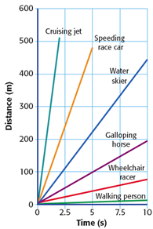
- __________________________ is the speed of an object in a particular _____________________.
- Velocity describes both __________________ and the ___________________.
Math Skills
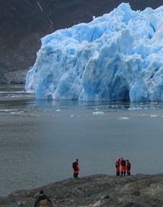 | Velocity – Metal stakes are sometimes placed in glaciers to help measure glacier’s movement. For several days in 1936, Alaska’s Black Rapids glacier surged as swiftly as _______ meters per day _______ the valley. Find the glacier’s velocity in meters per second (m/s). Remember to include direction.
Given:
Unknown:
Perform conversions:

Use the equation for speed:
$$Speed= \frac{distance}{time}= \frac{ }{ }$$
Write the velocity by including direction:

