FPS – Metric Conversion group practice

Names______________________________________________________ Period__________
I can…
Interpret word problems involving metric conversions.
Calculate measurements using scientific notation and metric conversions.
In your groups, complete each section below. Each person in your group must be the recorder at least once. Write their name in the box for each section. You must all work together to complete each section. Get Ms. Perry’s initials in the final box to move on.

Section 1- Recorder Name:_________________________

Fill in the chart with prefixes to use for the rest of the stations.
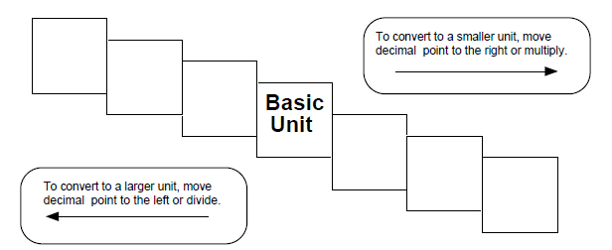
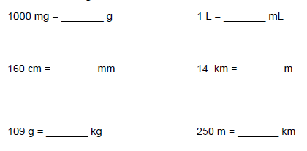
Ms. Perry’s initials

Section 2- Recorder Name:_________________________

Show all of your work with the factor label method. Will rode 2 kilometers on his bike. His sister Sarah rode 3000 meters on her bike. Who rode the farthest and how much farther did they ride (answer in km)?

Shrek wants to send a box of giant slugs to a friend by mail. The box of slugs cannot exceed a mass of 10 kg. If each slug has a mass of 200g, what is the maximum number he can send?

Carlos has a 1.2 meter long pizza. He wants to cut it into 3 equal, square pieces. How long should each piece be in millimeters?

Ms. Perry’s initials

Section 3- Recorder Name:_________________________

Michelle exercises for half an hour every day. How seconds in total does she exercise for over 5 days?

After she has run for half an hour, Michelle’s body temperature is about 99.0 º Fahrenheit. What is her body temperature in Celsius? In Kelvin?

To enhance her fitness, Michelle wants to make sure she is consuming 50g of protein a day. She eats a yogurt (1100 mg protein) for breakfast, a glass of milk (800 mg) after working out, and two pieces of chicken for lunch (2100mg each). Has she hit her goal? If not, how much more protein does she need for the day?

Ms. Perry’s initials

Section 4- Recorder Name:_________________________

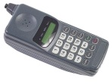
Your current cell phone is 1.2 centimeters thick. How many millimeters is this? How many meters?

You would like to purchase a cell phone that is more sleek and thin than your current one. A salesperson is weirdly offering cell phone sizes in meters. The two options given are a model that is 0.12 m thick and 0.020 m thick. What are these cell phone sizes in centimeters? Which is a good choice?

You give up on this salesperson and go to a Verizon store, where everything is in inches. UGH. Find what your current cell phone is in inches if every 1 inch is 2.54 centimeters. Would a 0.2 inch model be a better choice than your current cell phone? Why or why not?

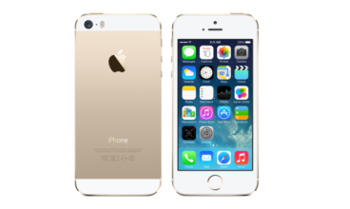
Ms. Perry’s initials

