FPS – Measurement (cont’d)

Name____________________________ Period__________

Bellwork
Bellwork: What do you think the different is between accuracy and precision?
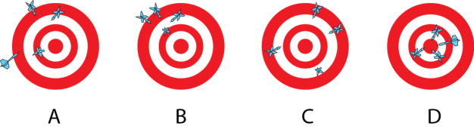

- Significant Figures

2. Scientific notation
A way of expressing a value as _______________________________________________
300,000,000 m/s ______________________________
Exponent indicates __________________________________________________________
Exponent is positive:_______________________________ Exponent is negative:__________________________
- 4.2 x 10⁴ ___________________________
- 3.9 x 10⁻⁶ ___________________________
- 450,000 ____________________________

3.Temperature Conversions  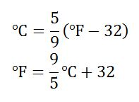 or 5F˚ = 9C˚ + 160 | SI Unit: Kelvin  K = C˚ + 273  C˚ = K – 273  MUST be in Celsius to get to Kelvin  0K = absolute zero

