FPS – Measurement

Name____________________________ Period__________

bellwork
Bellwork: What did you notice from the candle lab? How did you revise your hypotheses?
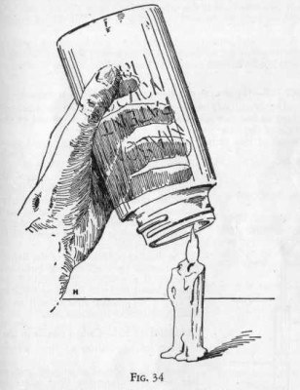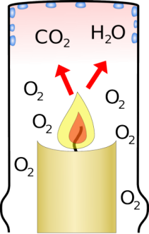
- What are some things you measure in your daily life? Why?

2. What are some things we measure in science?

3. Let’s hear what Bill Nye has to say about measurement.

Notes
4. Why is it important to have a standard system of measurement?

Systeme Internationale (SI Units)
Quantity | Name | Symbol
Length
 | Kilogram
Time
Electric current
Temperature
 | Mole
Luminous intensity

Derived Units
Quantity | Name | Symbol
Area (l x w)
Volume (l x w x h)
Speed
Acceleration
Density

5. King Henry Died by Drinking Chocolate Milk
kilo hecta deka BASE deci centi milli
meter, liter, gram
1000 100 10 1 0.1 0.01 0.001

6. Factor Label method steps:
- Write given number over 1.
- Multiply the given by a fraction set up with the unit you were given on the bottom, and the unit you need to convert to on the top.
- The larger unit gets a 1. The other unit gets the conversion factor.
- Multiply the numbers on top, divide by the numbers on the bottom.
- Cancel out units that appear on the top and bottom.
- Rewrite with the final units.

A dose of placebo is 2000 mg of sugar. How many grams is this? You run a 104 km race. (WHOA) How many
meters is this?
2000 mg x ________ = ________g 104 km x ________ = ________m

