FPS – Heating Curve Demo and Practice

Name____________________________ Period__________

I can…
Interpret a heating curve.
Construct a heating curve based on given properties.
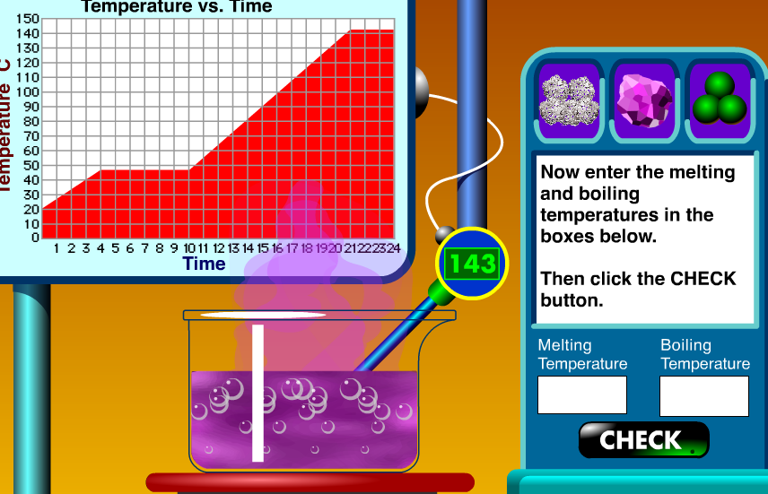
Pre-Lab Questions – Complete quietly on your own first!
- A heating curve often shows 3 different states of matter. List them.
- A heating curve show many different phase changes. List as many as you can remember.
- Look at the heating curve above. What is the melting/freezing point?

Lab Demonstration
- On the graph to the right, sketch the heating curve. | 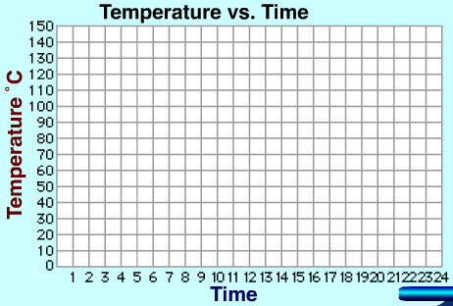
- Remember, the flat, horizontal lines are phase changes. What two phase changes occurred, at the same temperature?
- What is the melting and boiling point?
- What happens with energy at diagonal lines? At horizontal lines?
- On the graph to the right, sketch the heating curve.
- What is the melting and boiling point?

- On the graph to the right, sketch the heating curve.

Answer the following questions on your own!
Using the heating curve, answer the following questions, get them signed by your teacher.

- What state of matter is the substance at segment 1?
- What two phase changes are occuring at the same time on segment 2?
- What is the boiling point of the substance? (Hint: see segment 4)
- What state of matter was the substance at 75°C?

- What is the melting point of the substance?

Now… do the quiz on your phone or laptop!! Go to join.quizziz.com and enter the pin.

