FPS – Chapter 16 - Unit 5 Review

Name____________________________ Period__________

- What are the scales of temperature? What are the formulas to convert among them?
- Define Heat and temperature.
- What does temperature measure?
- How does the speed of particles affect the temperature?
- How does a thermometer measure the kinetic energy?
- What is the formula for calculating heat? Write the formula, define each variable, and give its appropriate unit(s).
- What are the 3 types of thermal energy transfer? Define them.

- What is a calorimeter?
- What is an example of each type of heat transfer?
- Define the 3 laws of thermodynamics.
- What is the difference between forced and natural convection?
- How do we typically heat our homes?
- Explain what coats, jackets, curtains and other insulators do.
- What are the types of systems we use to harness heat for our convenience and how do they work?

$°C=\frac{5}{9} (°F-32)$ °$F=\left(\frac{9}{5} °C\right)+32$ $K=°C+273$ $°C=K-273$
$Q=mCΔT$
Fahrenheit | Celsius | Kelvin
220 °F
 | 25°C
 |  | 266 K
 | 39°C
70°F

25. Gold has a specific heat of 0.129 J/g°C. How many joules of heat are required to raise the temperature of 25 grams of gold from 20°C to 86°C?

26. Graphite has a specific heat of 0.709 J/(g°C). If a 15 gram piece of graphite is cooled from 35 °C to 18 °C, how much energy was lost by the graphite?
27. If 335 g of water at 69 °C loses 9750 J of heat, what is the final temperature of the water? Liquid water has a specific heat of 4.18 J/(g°C).

28. How much heat was absorbed by 100 g of water if the temperature of the water went up 10ºC. The specific heat of water is 4.2 J/(gºC).

29. Let’s assume the heat lost by a piece of metal is absorbed by the water from the previous question. What is the specific heat of the metal if the temperature of the metal went down 55ºC and the mass of the metal was 50 grams.

30. See the diagram below. Label the varying points and lines on the diagram. 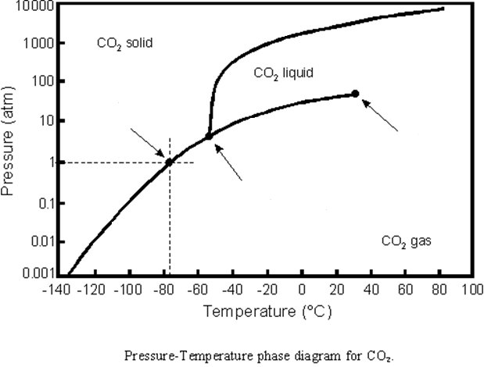
a. What is normal pressure?
b. What would happen at normal pressure if you raised the temperature from -120 degrees Celsius to -40?

31. See the image below. Which sample of particles has a higher temperature AND why?
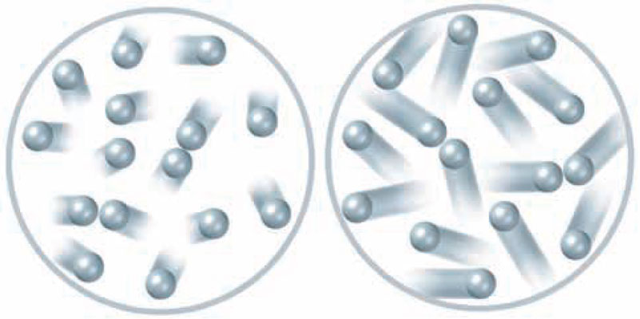

32. See the heating curve for water below. Fill in the missing terms.
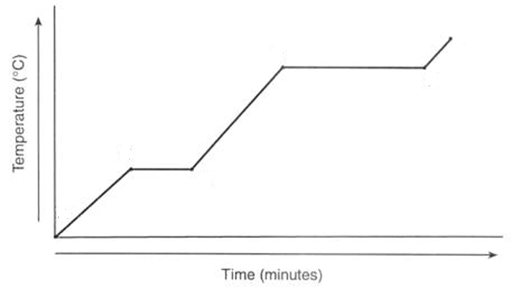

100°C -
0°C -
- You have water in a cup at -10°C . What state of matter is the water?
- You take that water at -10°C and travel to Ecuador where the temperature is 30°C. What phase change occurs?
- You put that water in a pot on the stove and heat it to 108°C, which causes it to boil. Then, you quickly cool it to 48°C by putting it in a refrigerator. What phase change occurs?

