FPS – Free-body diagram stations

Names______________________________________________________ Period__________
I can…
Define all the common forces in free-body diagrams.
Calculate net forces.
In your groups, complete each section below. Each person in your group must be the recorder at least once. Write their name in the box for each section. You must all work together to complete each section. Get Ms. Perry’s initials in the box to move on.

Section 1- Recorder Name:_________________________

A penguin slides on his stomach down an icy hill. Ignore frictional forces. Draw the free-body diagram.
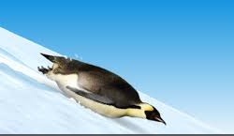
The penguin reaches the bottom of the hill and dives into the water. List the forces (and be specific!) acting on the penguin when he is swimming.

The penguin leaps out of the water. Draw the free-body diagram of the penguin the moment it is in the apex of its jump. (Not touch any other surfaces.)

Section 2- Recorder Name:_________________________

What type of situation would be happening if the free-body diagram looks like this? EXPLAIN how you know.
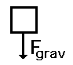
Explain, in detail, the forces and motion in the following free-body diagram.
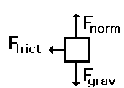

Carefully look at the magnitude and directions of the arrows in the diagram below. Create a story for the diagram.
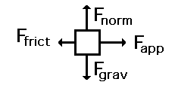

Section 3- Recorder Name:_________________________

Draw a free-body diagram for an object at terminal velocity and another for an object at rest on the ground. What do you notice?

Draw two free-body diagrams for an object in free-fall accelerating very quickly toward the Earth: one with air resistance included, one without.

Create a total of 3 free-body diagrams for each part of the following story.
An egg sits at rest on a shelf. The egg is knocked from the shelf and given initial forward velocity as it falls to the ground in a curved path. Finally, the egg breaks as it comes to rest on the floor.

Section 4- Recorder Name:_________________________

Find the net force of all the situations below. Be sure to write the directions as well.
-20 N
20 N
-40 N
20 N
20 N
-10 N
10 N
-10 N
65 N
-20 N

Draw a free-body diagram for a car accelerating to the left. Gravity pulls with a force of 50 N and the normal forces of the road push with 50 N as well. The car applies a force of 300 N to the left, while the rolling friction pushes back with 50 N. Label all forces and find the net force’s magnitude and direction.

