FPS – Forces Notes

Name____________________________ Period__________

I can…
Define force, gravity, and projectile motion.
Explain types of friction.

Forces - Notes
Bellwork – See the image to the right. What are pushes and pulls acting in this image? Write your ideas below.  ______________________________________  ______________________________________  ______________________________________  ______________________________________ |  | 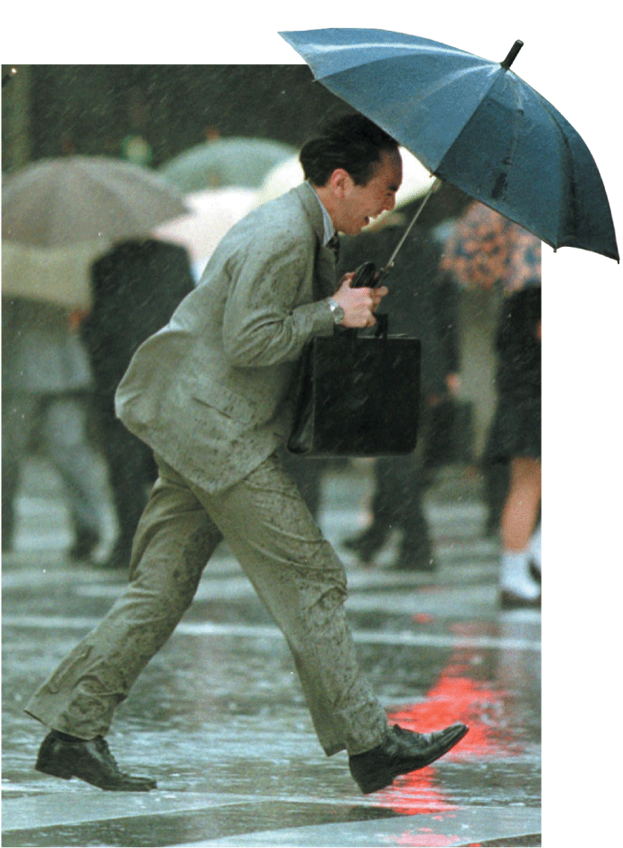
- What is a force?
____________________________________________________________________
- How do forces affect the motion of an object?
____________________________________________________________________
____________________________________________________________________
____________________________________________________________________
____________________________________________________________________
- How do we measure force?
The unit ___________________________ which represents the force that causes _____________________________________________________________________
_____________________________________________________________________
1 N =
- How do we represent forces?
We can use __________________ to show ____________________ and _______________________ of forces.
- We can combine forces to determine whether they are ____________________ or ____________________. Which do you think is happening in the picture to the right?  ___________________________ | 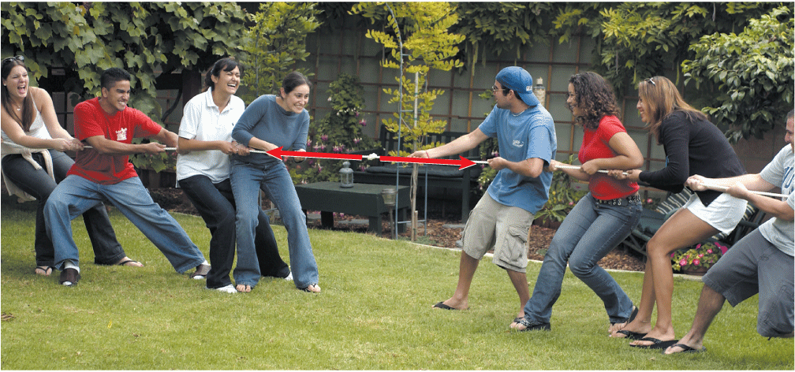
- ______________________________ are forces that combine to produce a net force of zero, and do not ___________________________________ of an object.
- _______________________________ are forces that combine to produce a net force not equal to zero and cause a _____________________________.
- How do we combine forces?
Look at the ____________________ and ___________________ of each force, and add them.
For our purposes, forces to the right and up will be __________________ and forces to the left and down will be ___________________.
- Combine the following forces.
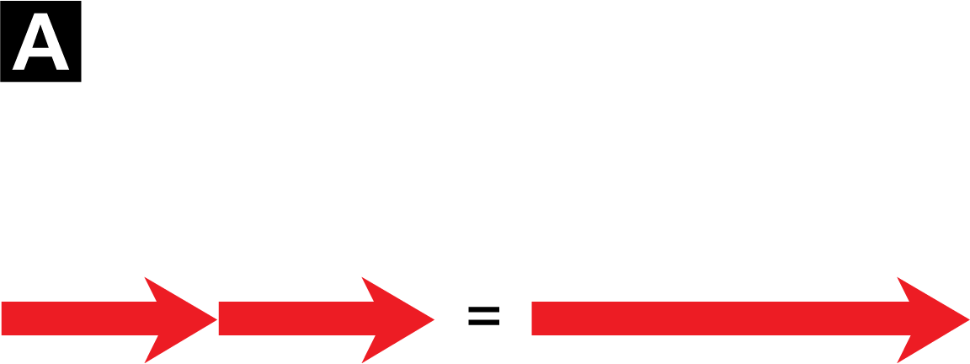
20N
20N

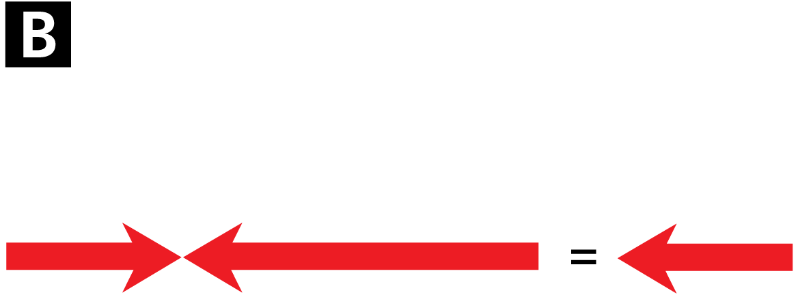
-40N
20N
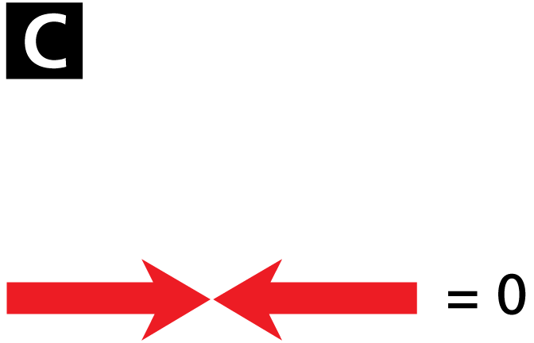
20N
-20N

Which are unbalanced? _________ Which are balanced?____________
- What is friction?
________________________________________________________________
________________________________________________________________
- What are the four main types of friction?
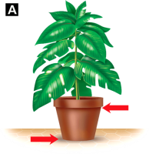
- ______________________ is the friction that acts on objects that ____________________________________________________.
It is always acting in the direction _______________ of _______________ force.
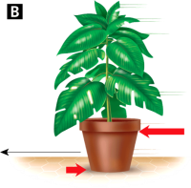
- ____________________ is a force that _______________________ of an object as it _________________________________________. It is less than static friction.
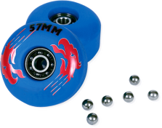
- _____________________ is the friction force that acts on ______________________________. It is about ___________________ times less than static or sliding.
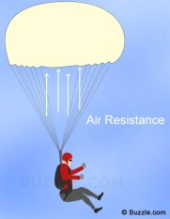
- _____________________ opposes the motion of an object through ______________________. When it acts on an object through air, it is called _____________________________ (or drag). As the speed of the object increases, the fluid friction _______________________.
- What is gravity?
_________________ is a force that acts between _____________________________. It is an _______________________ force and can act over __________________________________. It pulls ______________.
- Based on what we know, let’s try and describe the forces at play in this image of a boulder resting on a cliff.
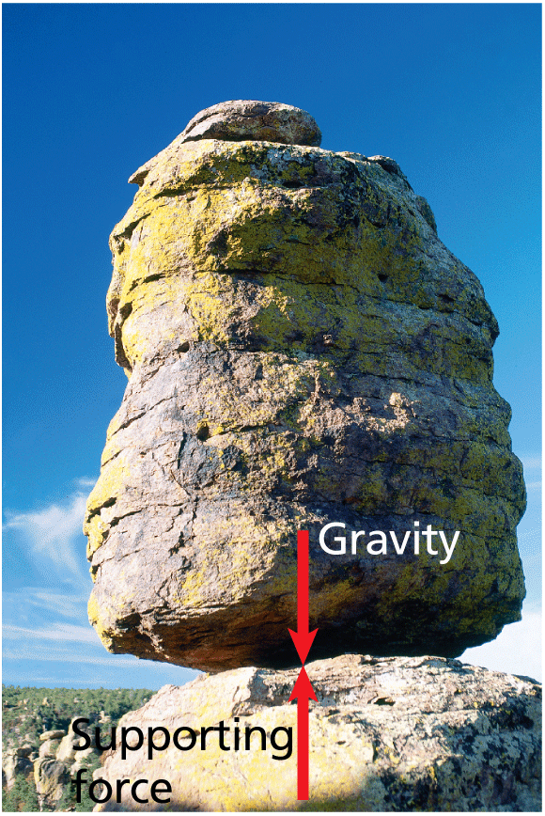
What about for this person falling with a parachute?
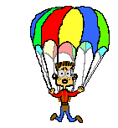

- What happens to falling objects?
Both ___________________ and _______________________ affect the motion of a falling object.
As objects fall to the ground, they gain speed so they ____________________.
The ________________________________ is the constant velocity of a falling object when the force of _______________________ equals the force of _____________________________.

- What happens when changing forces on falling objects?
When you throw a ball, it follows a _____________________. But why?
It falls in ______________________________ which is the motion of a falling object (or a _____________________) after it is given an ___________________________________________. Air resistance and ____________________ act on the projectile.
Compare images A and B. Which is a projectile?
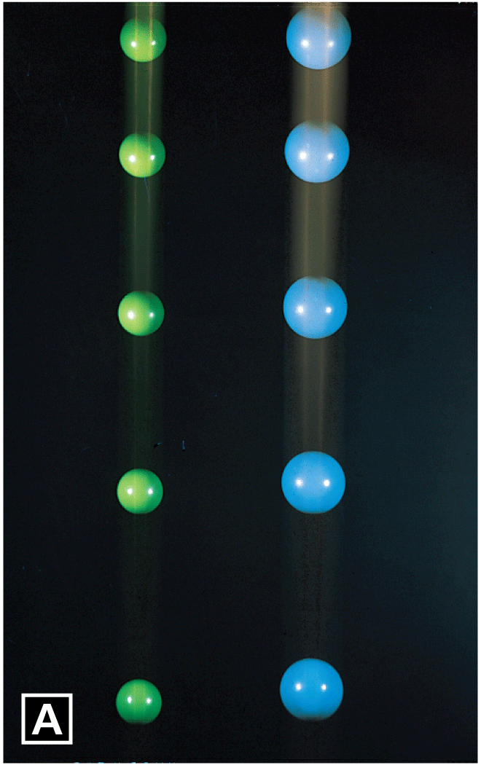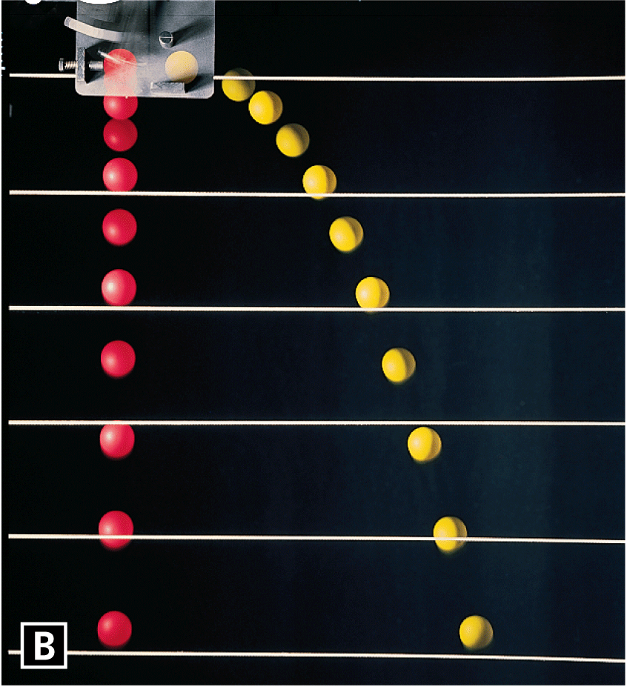

Which will hit the ground first?

Practice Questions
Try these on your own or with a neighbor and then we will check our answers!
- If an object is at rest, what must be true of the net force?

- Give an example of the each of the 4 types of friction.

- Describe two properties of the Earth’s gravity.

- Why do projectiles follow a curved path?

- Define the units of force.

