FPS – Forces and Motion Virtual Lab

Name____________________________ Period__________

Pre- lab Practice
Joe needs to push a file cabinet across the room. He begins by just looking at it. (Scene 1) He then begins pushing on the file cabinet. At first, the file cabinet does not move. (Scene 2) Then the file cabinet begins to slide. (Scene 3)
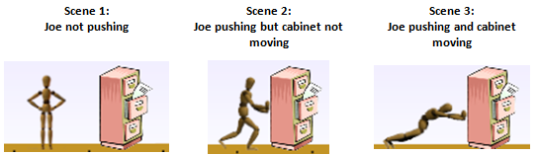
- Use free-body diagrams or arrows to describe all the forces you think are acting on the cabinet in each scene.

2.Why do you think the file cabinet moves in scene 3 but not in 1 or 2?

3. If the floor were covered with ice, how would the motion of the cabinet change?

- Grab a computer
- Go to http://shhsphysicalscience.weebly.com
- Mouse- over Foundations Physical Science Click Week 8 Click “Forces and Motion Virtual Lab”

I can…
Create and interpret free-body diagrams.
Analyzes forces to predict changes of motion.
Work with your partner(s) to answer the following questions.
Part One: Balanced and Unbalanced Forces
- Play with the “Introduction” tab by applying forces in each direction and change in the objects. Describe what you are noticing below.

- Change your object to the filing cabinet. 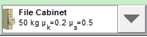
Using the simulation this time to help you, add arrows to the file cabinet in the images below. Label your arrows!

- Describe what is necessary to start the file cabinet moving.
- Compare the Applied Force arrow and the Friction Force arrow when the cabinet is stationary and when the cabinet is moving.
- What is similar? ________________________________________________
_______________________________________________________________
- What is different? _______________________________________________
_______________________________________________________________
- In which scene(s) are the forces balanced?
- In which scene(s) are the forces unbalanced?

Part Two: Applied, Friction, and Net force
- Still on the Introduction tab, we will examine friction. Describe what happens to the Friction Force arrow as you apply more and more force in one direction.

- What happens to the Friction Force arrow once the cabinet starts moving?

- What happens to the Friction Force when an object is stopped?
- Change the object to a Sleepy Dog.
Check the box that says “Sum of Forces”. 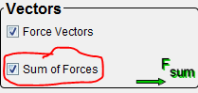
Describe anything you notice that is different about moving this object.
- In the Applied Force textbox, type in 125 Newtons of force. Describe what happens to the motion of the dog. (Hint: be specific about the velocity.)

- Sketch the free-body diagram of the dog to the right. Label all arrows.
- Press the pause button, and then type in 200 Newtons of force to the applied force and press enter. With the motion still paused, what has changed?

- Sketch the free-body diagram of the dog now. Label all arrows. Include a net force arrow.
- Can you find 3 different ways to change the net force on the dog? List the ways below.

Part Three: Forces and Changes in Motion
- In the same tab and still working with the Sleepy Dog, we will examine changes in speed. Apply a small about of force. How much does the dog’s speed change?
- Apply a large about of force. How much does the dog’s speed change?
- Using your answers to #16 and #17, make a statement about the relationship between applied force and an objects change in speed.

Post-Lab Individual Work
Work on the following problems on your own. When you are done, text in your response to the poll on the board.

- Jill is moving a sleepy dog at a constant velocity. Sketch the free-body diagram.
- Jill then begins moving the sleepy dog at a rightward acceleration. Consider friction. Sketch the free-body diagram.
- Comparing #1 and #2, list all the things about the motion and forces that changed.
- If the floor were covered in ice, how would the motion and forces on the object change?
- The sleep dog weighed about 25 kg. What would change if Jill were moving a 3 kg book?

- How useful for your learning was this science activity, compared to other science class activities? (circle)
More useful About the same Less useful
- How enjoyable was this science class activity, compared to other science class activities? (circle)
More enjoyable About the same Less enjoyable

