FPS – Energy Types and Conversion

Name____________________________ Period__________

I can…
Define the law of conservation of energy.
Distinguish between types of energies.

Energy Types - Notes
Bellwork – List as many types of energies as you can.  ______________________________________  ______________________________________  ______________________________________  ______________________________________ |  | 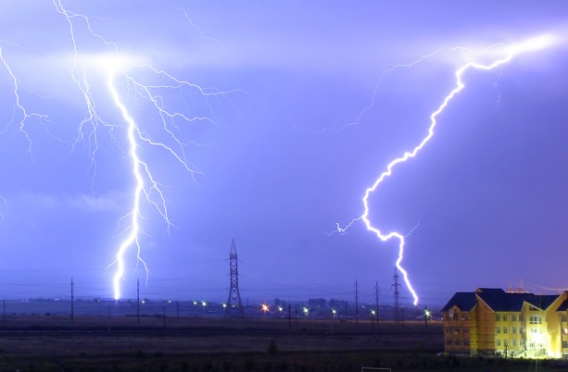
- What are the forms of potential energy?
____________________________________________________________________
- What is elastic potential energy?
____________________________________________________________________
____________________________________________________________________
____________________________________________________________________
____________________________________________________________________
- A-Predict | B - Observe |  | C - Explain
- How does the experiment demonstrate elastic potential energy?
_________________________________________________________________
_________________________________________________________________
- What are the major forms of energy?

- __________________________________________ is the ________ of ________________________________________________________.
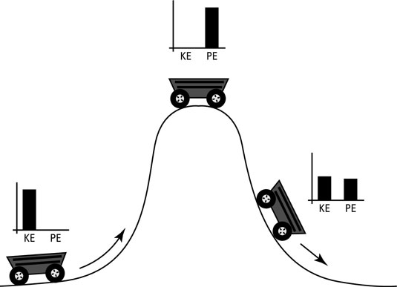
- ___________________________ is the total potential and kinetic energy associated with the ______________ of all the ________________ in an object.  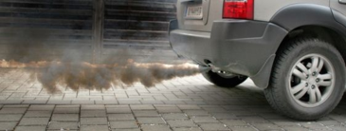  - ____________________________ energy is the energy _____________________ in chemical ________________________.  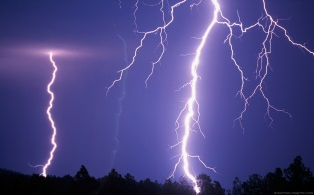  - ____________________________ energy is the energy associated with _______________________that do work.  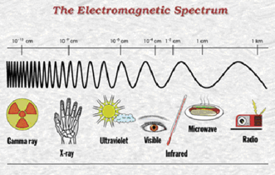  - ______________________________________ is the energy that ___________________________________________ in the form of ____________.  - _________________________ energy is the energy ____________________ in the atomic ________________________. Energy is ________________ during nuclear _____________________ and _____________________. |  |  |  | 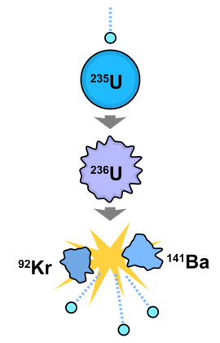  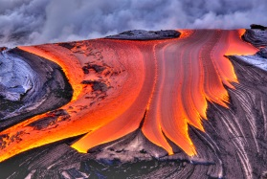
- Energy can be ______________________________ from one ________________ to another.
- The ________________________________________________ states that energy cannot be __________________ or ___________________.
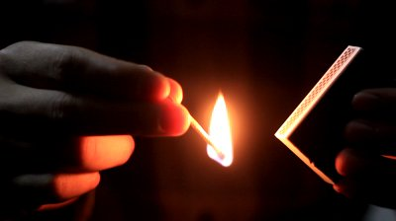

Practice Questions
Try these on your own or with a neighbor and then we will check our answers!
- List and give an example of each of the major forms of energy.

- Can an object have both kinetic and potential energy at the same time? Explain.

- What energy conversions occur when lighting a match?

- What force(s) could produce thermal energy?

