Electromagnetic Spectrum and Waves

Name____________________________ Period__________

I can…
Relate behaviors and parameters of waves to the electromagnetic spectrum.

EMS and Waves – Review Packet
Bell work: On your own, fill in as many parts of the spectrum as you can.
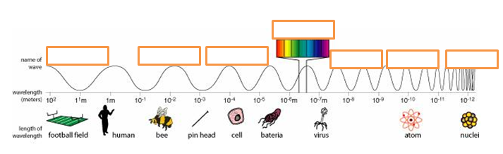
applications

- Using the electromagnetic spectrum, answer the questions below independently and get Ms. Perry’s initials when you’ve completed them.
- The highest frequency wavelength on the spectrum would be ________________ rays.
- Our eyes are tuned to about 400-700 nanometers, which represents the ____________________ region of the spectrum.
- A large type of wave that is often utilized for communication purposes is a __________________ wave.
- A common heat lamp that can be used to heat food uses waves just outside of the visible light region called ___________________.
- In moderation, ______________________ rays can help the body absorb vitamin D, but in excess can cause skin damage and cancer.
- With its small wavelength, the ______________ is especially useful in medicine to create images of our bodies beneath our skin.
- A useful device to heat food, as well as your phones, use _________________.

- Let’s play with some lasers.
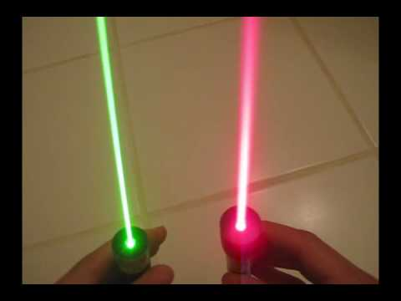
- Using the electromagnetic spectrum, which has a HIGHER frequency, the red or green laser? _________________________
- Which has a LONGER wavelength? __________________
- Which has HIGHER energy? __________________
- Predict – what do you think will happen when we shine a laser through this jug? Write your prediction then compare with a neighbor.

- Observe – watch what happens, then record your observations. Discuss with a neighbor.

- Explain - This is happening due to a specific behavior of a wave. Anyone remember what it is?

- What are the other behaviors of waves we discussed?

- Let’s start reviewing the rest of the waves unit. Try using “FPS – Wave notes”, “FPS – Waves Notes 2” and “FPS – Sound and Light notes”. When you’re done, text in on the board!
- Define a wave.
- What is a medium? Give several specific examples.
- What are two types of mechanical waves?
- How are these two types different?
- Draw and label the parts of a wave.
- Describe the relationship between energy, frequency, and wavelength.
- What is the frequency of a wave?
- What is the period of a wave?
- What is the speed of a wave?
- How can we find the speed of a wave?
- If a wave has a wavelength of 1.2 m and a frequency of 0.9 Hz, what is its speed?
- If a wave has a wavelength of 0.99m and a speed of 62 m/s, what is its frequency?
- If a LIGHT wave travels at the speed of light at a frequency of 1,114,000 Hz, what is its wavelength?
- What happens to sound as you increase the amplitude?
- What happens to sound as you increase the frequency?
- Describe the Doppler Effect in a scenario using sound waves.
- Describe the Doppler Effect in a scenario using light waves.
- Text in on the board!

