FPS – Electric Current Notes

Name____________________________ Period__________

Electric current - Notes
Bellwork: What is required for electric current to flow?  __________________________________________________  __________________________________________________ | 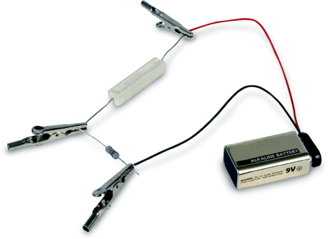
- What are two types of current?
____________________________________________________________________
____________________________________________________________________
- The continuous flow of electric charge is an ________________________.
- ____________________________________________________________________
____________________________________________________________________
- ____________________________________________________________________
____________________________________________________________________
The SI unit of electric current is the ___________(A), or amp, which equals 1 ______________________________.
Even though electrons flow in an electric current, scientists define current as the direction in which positive charges would flow.

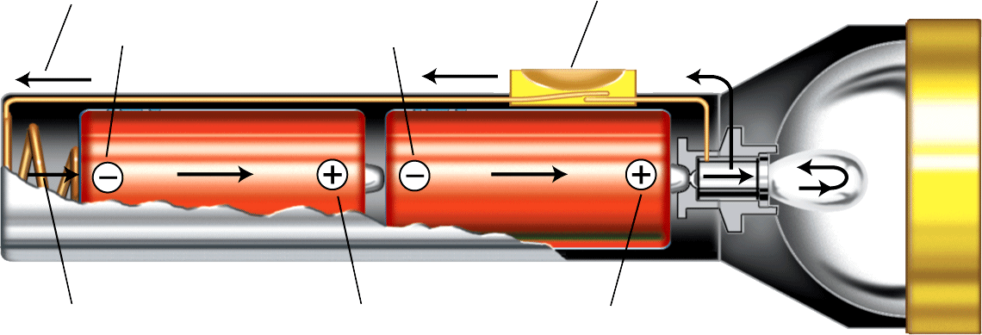
A _______________ is required for charge to flow in a flashlight. Batteries must be placed so that ___________ can flow from ___________________, passing through the bulb.
Flow of current
Negative terminals
Spring
Positive terminals
Switch

- _____________________________ is __________________________ to the flow of charges in a material.
As electrons move through a conducting wire, they collide with electrons and ions. These collisions convert some _______________________ into ___________________________, and the current is reduced.
The SI unit of resistance is the _________________.
- What factors affect electrical resistance?

- _______________________________________________________________________________
_______________________________________________________________________________
_______________________________________________________________________________
- Potential difference
Water falls spontaneously from a higher to a lower height. Likewise, electric charges flow from a higher to a lower potential energy.
_____________________________ is the difference in electrical potential energy between two places in an ______________________. Potential difference is measured in joules per coulomb, or ______________________. Because it is measured in volts, potential difference is also called ______________________.
- Voltage Sources
A source of voltage does ___________ to increase the potential energy of electric charges. Three common voltage sources are _______________________________________________________________.
A battery is a device that converts _________________ energy to electrical energy.
- How are voltage, current, and resistance related?
____________________________________________________________
____________________________________________________________
____________________________________________________________
____________________________________________________________
- Ohm’s Law
- According to Ohm’s law, the voltage (V) in a circuit equals the product of the current (I) and the resistance (R).
formula
- Let’s Review…
-How can we lower the resistance of a wire?
-What does the voltage between two points in an electric field represent?
-A 9-volt battery drives an electric current through a circuit with 4-ohm resistance. What is the electric current?

