FPS – Solutions Notes and Practice

Name____________________________ Period__________
Bellwork
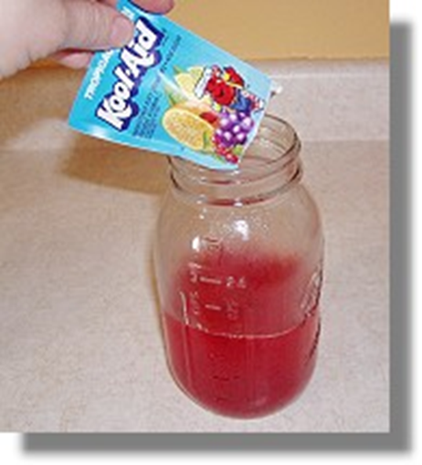 | - What do you remember about the difference between homogeneous mixtures and heterogeneous mixtures?
- Heterogeneous mixtures _________________________________________
  - Suspension _____________________________________________
Ex:_____________________
  - Colloid ________________________________________________
Ex:_____________________
  - Immiscible
  - Examples:
- Homogeneous mixtures ___________________________________________
Examples:____________________________
- Solutions are a group of _________________________ that are mixed up in a complete _________________ distribution.
- There are two parts in a solution.
  - The _____________________ is the substance that is ________________
Example: salt, sugar, Kool-aid powder
  - The _____________________ is the substance that is DOING the dissolving.
Example: __________________________
- Solubility is the ________________________ of the solvent to _________________ the solute. If liquids can mix and dissolve in one another, they are called __________________________________.

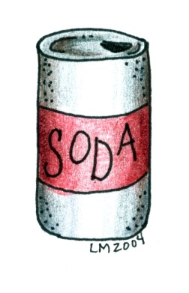
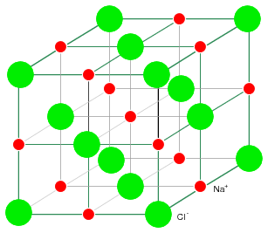
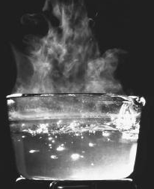
  - What factors affect solubility?
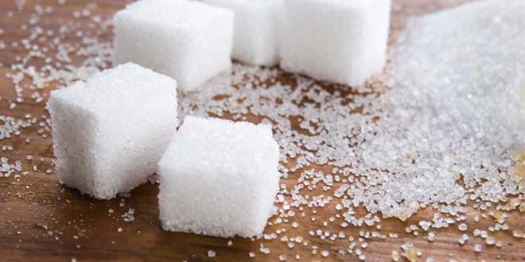
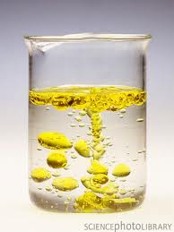
- “Like dissolves like”
  - Polar _____________________________________________
_____________________________________________________
  - Nonpolar _________________________________________
_____________________________________________________
- Concentrations
  - Dilute _____________________________________________
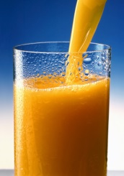
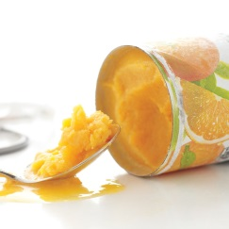
  - Concentrated _______________________________________
______________________________________________________
- We can also classify solutions based on amount of solute.
  - Unsaturated solutions have ________________ than the maximum amount of solute _____________________ in them. (This means more could be added, and the solute would continue to dissolve!)
  - Saturated solutions have the ______________________ amount of solute in them. No more can be made to dissolve.
  - Supersaturated solutions have ____________ than the maximum amount of solute in them. This is not possible for all solutions!
  - How do you think we could create a supersaturated solution?
__________________________________________________________
Solubility curves
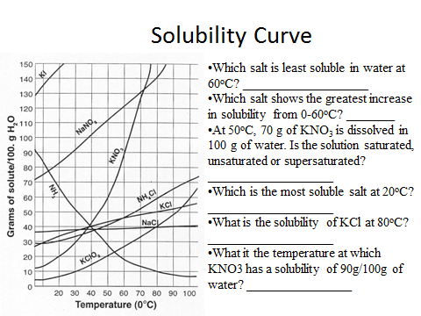
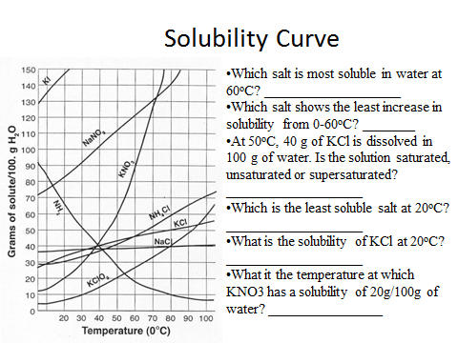

Acids and Bases
The Chemistry of Acids and Bases – Label the following an “acid” or a “base”
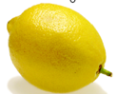 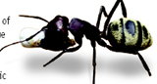 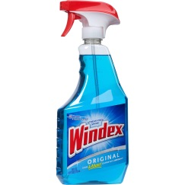 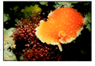
- What is an acid?
  - An _____________ is a solution that has an excess of ___________________. It comes from the Latin word acidus that means “sharp” or “sour”.
  - The more H⁺ ions, the more ____________________ the solution.
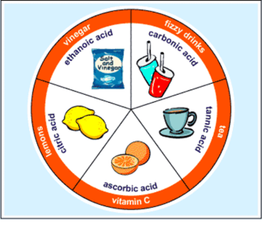
- Properties of an Acid
a. Tastes ________________
b. Conduct _______________________
c. ______________________________
d. Some acids react strongly with ______________________ to
produce H₂ (hydrogen gas)
e. Turns blue litmus paper __________________
f. Neutralize with a ________________
g. Strong acids fully _________________ in water. Weak acids have fewer hydrogen ions in solution.
- Uses of acids
  - Acetic acid = ___________________________
  - _______________ acid (lemons, limes, oranges)
  - Ascorbic Acid = _______________________ which your body needs.
  - Sulfuric acid is used in production of fertilizer, steel, paint, and plastics.
- What is a base?
  - A __________________ is a solution that has excess ___________________
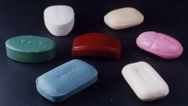
  - Another word for base is ____________________.
- Properties of a base
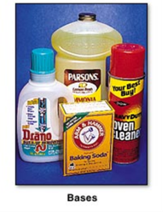
  - Feel ________________________
  - Taste _______________________
  - __________________________
  - Can conduct ____________________
  - _____ __________ ________________ with metals.
  - Turn red litmus paper __________________.
- Uses of bases
  - Bases give ______________, ammonia, and many other _____________ _____________________ some of their useful properties.
  - The OH⁻ ions interact strongly with certain substances such as dirt and grease.
  - _________________ and over cleaner are examples of bases.
  - Your blood can be slightly _______________ solution.
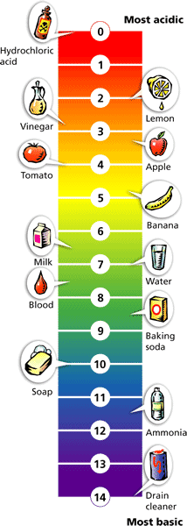
- pH Scale
  - pH means “potential ______________________” – measure H⁺
  - pH is a measure of how _____________ or basic a solution is.
  - The pH scale ranges from _______________________.
  - Acidic solutions have pH values _______________________.
  - A solution with a pH of 0 is very acidic.
  - A solution with a pH of 7 is ____________________.
  - ____________ ___________________ has a pH of 7.
Basic solutions have pH values of ________________________.

