FPS – Thermal Energy & Specific Heat Practice

Name____________________________ Period__________

- 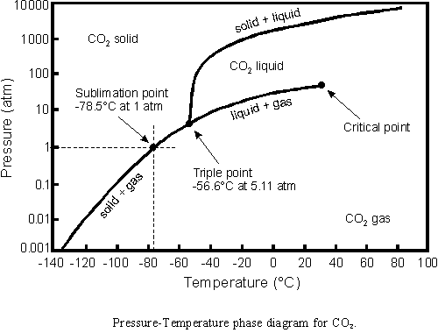 Above is the phase diagram for CO₂. Answer the questions using the diagram.
a. What is the sublimation point?
b. At 100 atm of pressure and -120 degrees Celsius, you have dry ice (solid CO₂). You raise the temperature rapidly to 0 degrees Celsius. What phase change occurs?
c. At what pressure and temperature are all three states in equilibrium?
d. At 10 atm of pressure, what temperature changes could cause evaporation?
- Label the heating curve below for water; indicate the states of matter for each diagonal line, the phase changes, and the temperatures for each.
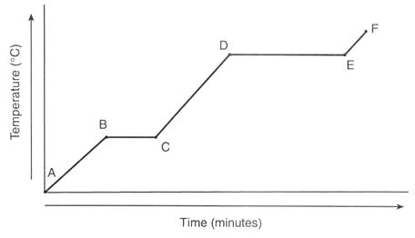
- Below is the formula for calculating heat. Label the variables and their units.

Q = m c ΔT

- Heat is not the same as temperature, yet they are related. Explain how they differ from each other.
- Gold has a specific heat of 0.129 J/g°C. How many joules of heat are required to raise the temperature of 15 grams of gold from 22°C to 85°C?
- An unknown substance with a mass of 100 grams absorbs 1000 J while undergoing a temperature increase of 15 °C. What is the specific heat of the substance?
- If the temperature of 34.4 g of ethanol increases from 25 °C to 78.8 °C, how much heat has been absorbed by the ethanol? The specific heat of ethanol is 2.44 J/(g×°C)
- Graphite has a specific heat of 0.709 J/(g×°C). If a 25 gram piece of graphite is cooled from 35 °C to 18 °C, how much energy was lost by the graphite?
- Copper has a specific heat of 0.385 J/(g×°C). A piece of copper absorbs 5000 J of energy and undergoes a temperature change from 100 °C to 200 °C. What is the mass of the piece of copper?
- 45 grams of an unknown substance undergoes a temperature increase of 38 °C after absorbing 4172.4 Joules. What is the specific heat of the substance?
- A 40 g sample of water absorbs 500 Joules of energy. How much did the water temperature change? The specific heat of water is 4.18 J/(g×°C).
- If 335 g of water at 65.5 °C loses 9750 J of heat, what is the final temperature of the water? Liquid water has a specific heat of 4.18 J/(g×°C).

- A 15.75-g piece of iron absorbs 1086.75 joules of heat energy, and its temperature changes from 25°C to 175°C. Calculate the specific heat capacity of iron.

- How many joules of heat are needed to raise the temperature of 10.0 g of aluminum from 22°C to 55°C, if the specific heat of aluminum is 0.90 J/g°C?

- To what temperature will a 50.0 g piece of glass raise if it absorbs 5275 joules of heat and its specific heat capacity is 0.50 J/g°C? The initial temperature of the glass is 20.0°C.

- Calculate the heat capacity of a piece of wood if 1500.0 g of the wood absorbs 6.75×104 joules of heat, and its temperature changes from 32°C to 57°C.

- 100.0 mL of 4.0°C water is heated until its temperature is 37°C. If the specific heat of water is 4.18 J/g°C, calculate the amount of heat energy needed to cause this rise in temperature.

- 25.0 g of mercury is heated from 25°C to 155°C, and absorbs 455 joules of heat in the process. Calculate the specific heat capacity of mercury.

- If a sample of chloroform is initially at 25°C, what is its final temperature if 150.0 g of chloroform absorbs 1.0 kilojoules of heat, and the specific heat of chloroform is 0.96 J/g°C?

