FPS – Bonding and Naming Chapter 6 - Unit 10 Review

Name____________________________ Period__________

- Bonding
- Define the following bonding types and give examples of the compounds that are bonded in that way.
  - Ionic
    - Examples:
  - Covalent
    - Examples:
  - Metallic
    - Examples:
- What are some identifying properties of ionic bonds? How are the ions arranged?

- What are some identifying properties of covalent bonds? How are the units different from ions?
- What are some identifying properties of metallic bonds? How are the electron interactions unique?
- Describe the differences in valence electron behavior for each of the 3 bonding types.
- What is the octet rule? How do atoms satisfy the octet rule?
- How are the bonds in H₂O different from the bonds in Li₂O?
- On the periodic table below, identify the 3 main categories of elements. Then, label the charges for each column.
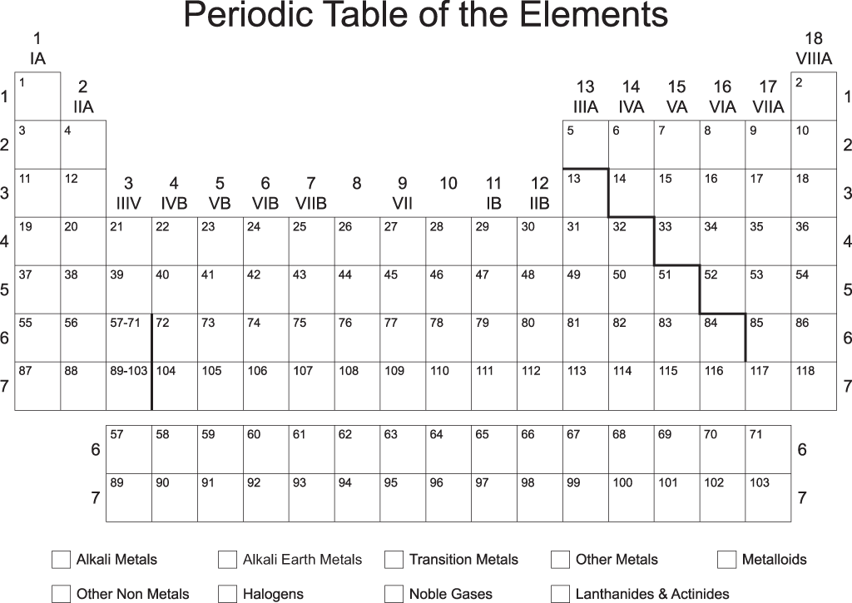

- Lewis Dot Structures and Bonding

- What is depicted in a Lewis dot structure?
- Draw the Lewis dot structures for the following elements:
  - Carbon
  - Aluminum
  - Lithium
  - Helium

  - Argon
  - Phosphorus
  - Silicon
  - Oxygen
  - Fluorine
- Draw the Lewis dot structures for the following compounds. Remember, subscripts tell you the number of atoms present per unit.
  - H₂O
  - CH₄
  - LiCl
  - Na₂S
  - O₂
- Write the chemical formulas for the ionic compounds containing the following elements. Refer to #8 for charges to use the crossing method.
  - Na and O
  - Ca and Cl
  - Mg and N
  - Cs and F

C. Naming Binary Compounds
- What are the differences in naming covalent and ionic compounds?
- When do you NOT use a prefix for a covalent compound?
- Fill in the prefix table below.
Prefix | Number
 | 1
 | 2
 | 3
 | 4
 | 5
 | 6
 | 7
 | 8
 | 9
 | 10

- Name the following ionic compounds:
  - NaCl
  - MgF₂
  - AlCl₃
  - BeO
- From the following names, write the chemical formula for the ionic compounds. Write the ions first, then use the crossing method.
  - Sodium oxide
  - Magnesium oxide
  - Barium fluoride
  - Lithium bromide
- Write the names for the following covalent compounds.
  - CO
  - CO₂
  - N₂H₄
  - SO₄
  - N₃O₅
  - CS₆
- Write the formula for the following names.
  - trisilicon tetrafluoride
  - carbon trioxide
  - dichlorine heptoxide
  - tetracarbon decasulfide
  - boron hexachloride
  - dihydrogen dioxide
- Below is a mixed set of chemical compounds. Ionic and covalent are both present. Name or give the chemical formula.
  - CaO h. Potassium bromide
  - H₂O₂ i. Nitrogen trioxide
  - Carbon dioxide j. NO
  - Magnesium oxide k. SF₆
  - PCl₃ l. Strontium nitride
  - NH₂ m. Diphosphorus pentoxide
  - Dinitrogen monoxide

