FPS – Bohr Models

Name____________________________ Period__________
 | Figuring out the particles
 | 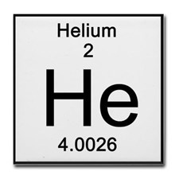
- Atomic number = number of __________________________
= number of __________________________
So for Helium: electrons ________ protons _________
- Mass = neutrons + protons
Neutrons = mass – protons
So for Helium: mass ________ -- protons _________ = neutrons _________
- Recap: Helium has _______ protons ________ neutrons ______ electrons
- In the nucleus, let’s just write the number of protons and neutrons.
- Now, add electrons to the first shell.
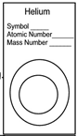
1st energy shell = ________ electrons
2nd energy shell = ________ electrons
3rd energy shell = ________ electrons

If you fill the 1st , add to the 2nd!
If you fill the 2nd, add to the 3rd!
- When protons = electrons then it is a _____________________________
- When there are more protons than electrons, it is a _____________________
- When there are less protons than electrons, it is a ______________________
- When there are a different number of neutrons, it is an _____________________.

Element |  | Atomic # | Atomic Mass | Protons | Neutrons | Electrons | Bohr Model
Carbon |  | 6 | 12 | 6 | 6 | 6
Hydrogen |  | 1 | 1
Lithium |  | 3 |  | 3 |  | 3
Magnesium |  | 12 | 24

