FPS –Atomic Theory Notes

Name____________________________ Period__________

I can…
Define the parts of an atom.
Distinguish between historic models of the atom.

Notes
- Atom

- The ___________________________________ of an element that still has the
_________________________ of that element.

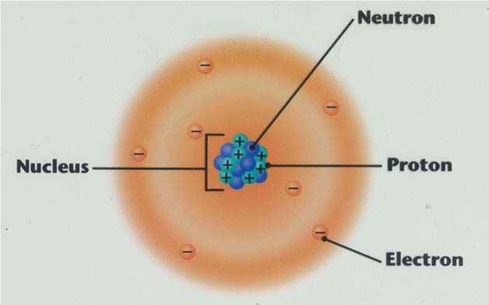

- Compounds – Counting atoms
- Made of ________________________ of elements.
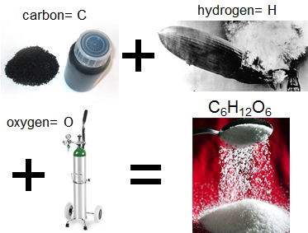
- ____________________________ of compounds often ________________
from the properties of _____________________ that make them up.

- Ex: C₆H₁₂O₆ = _________________________ (sugar)
- 6 _____________________ atoms
- 12 _____________________ atoms
- 6 _____________________ atoms

- Atomic Theory – The Beginning

__________________ believed that the tiniest particle was the atom, which was the smallest thing that could ____________________________________.
He also thought that atoms were made of a _________________________________ that formed into different shapes and sizes.

Atomos ___________________________________________________

- John Dalton’s Atomic Theory
Based on scientific ___________________________ through __________________, John Dalton published a theory in 1803. His theory states these ideas:

- All substances are made of ________________. Atoms are small particles that cannot be ________________, __________________, or _________________________.
- Atoms of the same element are ________________________________. and the atoms of different elements are ___________________________.
- Atoms join with other atoms to make ______________________________.
- Disagreeing with Dalton
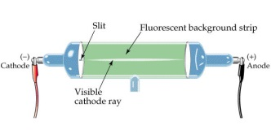
As scientists were able to gather new data, more discoveries about the atom showed some mistakes with Dalton’s theory.

J. J. Thompson discovered with a __________________________ that atoms contained ___________________-charged particles called ___________________. He came up with the ______________________________ model.

- Rutherford’s Atomic Discoveries
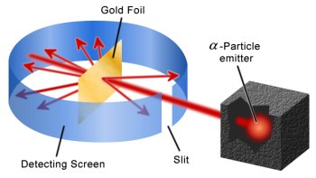
Later, one of Thompson’s students named Ernest Rutherford discovered the ________________________-charged particles in the center of the atom.
He designed the ________________________ experiment.

- Bohr’s Model and Modern Theory
With more experiments and evidence, Niels ____________ developed his model named after himself, called the ________________ model.

This model represents a small, positively-charged __________________ surrounded by _____________________ that travel in ___________________________ around the nucleus.
Modern Theory developed by scientists, especially Schrodinger and Heisenberg, states that electrons are found in probable ___________________ called ____________________________________.

Graphical Representation
Democritus’s Ideas – Atomos – 400 B.C.E.

Dalton’s Theory – Indestructible Sphere – 1803

Thomson’s Model – Plum-Pudding – 1897

Rutherford’s Model – Dense Nucleus – 1911

Bohr Model – Bohr Model – 1913

Modern Theory – Electron Cloud Model – 1926

Let’s Review…
- How were Democritus’s ideas different from Dalton’s ideas?
- Why did J. J. Thompson call his model the “plum-pudding” model?
- How did Rutherford, one of Thompson’s students, change the plum-pudding model to his own?
- What made Bohr’s model different from the others?

- What is different about the modern theory from the older models of the atom?

