FPS – Atoms Chapter 4-5 - Unit 9 Review

Name____________________________ Period__________

- History of Atomic Theory
- Summarize the following people’s discoveries and ideas. Dates/drawings will not be required on the test.
  - Democritus f. Rutherford
  - Atomos g. Gold-foil experiment
  - Dalton h. Bohr’s model
  - Thomson i. Electron-cloud model
  - Plum-pudding model

- What were some differences between Dalton and Democritus’s ideas?

- Who described the Billiard ball model? Why was it called such?
- Rutherford, who was Thomson’s student, refuted the plum-pudding model. Describe how his experiment did this.
- How is Bohr’s model different than previous models?
- How is the electron-cloud model different than previous models?
- What were Dalton’s three parts of his Atomic Theory of matter?
- According to Bohr’s model of the atom, where are the electrons? What can happen for them to change location?

- The Periodic Table & Atomic Structure
- How is the modern periodic table of element arranged?
- Assuming the atom is neutral, what does the atomic number tell you?
- Label the following periodic table square for argon.
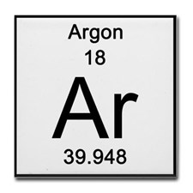
- What is a period? What does a period on the periodic table indicate about an element?
- What is a group/family? What does a group/family on the periodic table indicate about an element?
- What do valence electrons indicate about an element?
- What is an ion? What do we call a positive and negative ion?
- What is the octet rule? What are the exceptions?
- What does the mass number tell you? What are isotopes?
- In nuclear notation, write the isotopes magnesium-24, magnesium-25, and magnesium-26.
- Element Categories

- Describe properties of the alkali metals and give an example.
- Describe properties of the alkaline-earth metals and give an example.
- Describe properties of the transition metals and give an example.
- Describe properties of the metalloids and give an example.
- Describe properties of the halogens and give an example.
- Describe properties of the noble gases and give an example.
- What happens to metallic properties as you move from left to right on the periodic table?
- What happens to reactivity as you down a group on the periodic table?
- WHY do the alkali metals become more reactive down the group?
- WHY do the halogens become more reactive up the group?
- Give the trends of each of the following: metallic character, ionization energy, electronegativity, reactivity, atomic radius.

- Electron Configurations

- What are the 4 types of orbitals? How many electrons can each of them hold?
- Write the complete electron configuration for the following elements:
  - Potassium _____________________________________________
  - Lithium _____________________________________________
  - Aluminum _____________________________________________
  - Carbon _____________________________________________
  - Nitrogen _____________________________________________
  - Argon _____________________________________________
- Write the electron configurations for the following ions. Remember, if an ion is positive, it has lost electrons. If an ion is negative, it has gained electrons.
  - Be²⁺ _____________________________________________
  - B³⁺ _____________________________________________
  - Cl¹⁼ _____________________________________________
  - O²⁼ _____________________________________________
- Identify the errors in the following electron configurations. If there is no error, write “none”.
  - 1s²2s³2p² _____________________________________________
  - 1s²2s²2p⁶3s²4s¹ _____________________________________________
  - 1s²2s²2p⁸3s¹ _____________________________________________
- Write the electron configuration for the following orbital diagrams. Then, identify the element.
  - 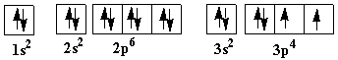
  - 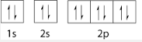
  - 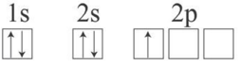

Use your periodic table and the images and formulas below as reference.

