FPS – Solutions Notes and Practice

Name____________________________ Period__________
Bellwork
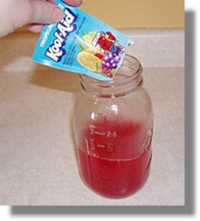 | - What do you remember about the difference between homogeneous mixtures and heterogeneous mixtures?
Acids and Bases
The Chemistry of Acids and Bases – Label the following an “acid” or a “base”
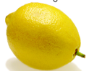 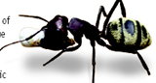 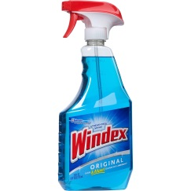 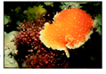
- What is an acid?
  - An _____________ is a solution that has an excess of ___________________. It comes from the Latin word acidus that means “sharp” or “sour”.
  - The more H⁺ ions, the more ____________________ the solution.
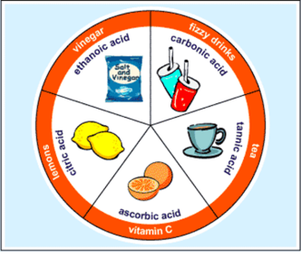
- Properties of an Acid
a. Tastes ________________
b. Conduct _______________________
c. ______________________________
d. Some acids react strongly with ______________________ to
produce H₂ (hydrogen gas)
e. Turns blue litmus paper __________________
f. Neutralize with a ________________
g. Strong acids fully _________________ in water. Weak acids have fewer hydrogen ions in solution.
- Uses of acids
  - Acetic acid = ___________________________
  - _______________ acid (lemons, limes, oranges)
  - Ascorbic Acid = _______________________ which your body needs.
  - Sulfuric acid is used in production of fertilizer, steel, paint, and plastics.
- What is a base?
  - A __________________ is a solution that has excess ___________________
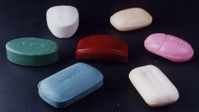
  - Another word for base is ____________________.
- Properties of a base
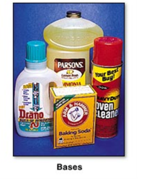
  - Feel ________________________
  - Taste _______________________
  - __________________________
  - Can conduct ____________________
  - _____ __________ ________________ with metals.
  - Turn red litmus paper __________________.
- Uses of bases
  - Bases give ______________, ammonia, and many other _____________ _____________________ some of their useful properties.
  - The OH⁻ ions interact strongly with certain substances such as dirt and grease.
  - _________________ and over cleaner are examples of bases.
  - Your blood can be slightly _______________ solution.
- pH Scale
  - pH means “potential ______________________” – measure H⁺
  - pH is a measure of how _____________ or basic a solution is.
  - The pH scale ranges from _______________________.
  - Acidic solutions have pH values _______________________.
  - A solution with a pH of 0 is very acidic.
  - A solution with a pH of 7 is ____________________.
  - ____________ ___________________ has a pH of 7.
Basic solutions have pH values of ________________________.

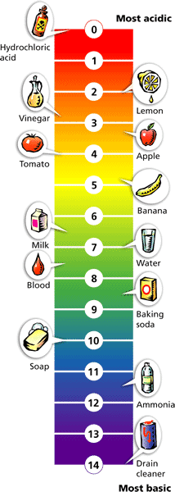

Acid‐base practice
Name____________________________Date____________Period_______
Circle the letter of the term or phrase that best completes each statement or answers each question.
1. Pure water has a pH of _____________.
2. A substance that produces OH‐ ions in a solution is ___________.

3. Identify each item below as to whether it refers to an acid, a base, or both an acid and a base. Use the letter in the key.
Key: A = acid; B = base; AB = acid and base
(a) _____ Produces hydrogen ions (H+) in solution.
(b) _____ Soaps are an example.
(c) _____ Can be detected with an indicator.
(d) _____ Lemon is an example.
(e) _____ Conducts electricity.
(f) _____ Is often corrosive.
(g) _____ reacts with metals.
4. Look at the list below of substances. Draw a pH scale in the space provided and arrange them to the best of your ability on it (you do not need to give exact pH values).
Sea water
Orange juice
Stomach acid
Human blood
Household bleach
Pure water
Tomato juice
Ammonia

