Formula Sheet
Density
$Density= \frac{mass}{volume}$ $1 gram H_{2}O=1 ml H_{2}O$ $Density of H_{2}O=1 g/ml$
$speed= \frac{distance}{time}$ $v=\frac{d}{t}$ $velocity= \frac{displacement}{time}$ $acceleration= \frac{change in velocity}{time}= \frac{(v_{f}-v_{i})}{t}$
g=9.8 m/s²
$Force=mass∙acceleration$ $F=ma$ $Weight=mass∙gravity$ $W=mg$
$momentum=mass∙velocity$ $p=mv$
$Work=force∙distance$ $w=F∙d$ $Power= \frac{work}{time}$ $P=\frac{w}{t}$
Work, Power, Energy
Motion
Forces
$GPE=mass ∙acceleration of gravity∙height$ $GPE=mgh$
$KE=\frac{1}{2} mass∙{velocity}^{2}$ $KE=\frac{1}{2}mv^{2}$
Waves
$Period= \frac{1}{frequency}$ $frequency=\frac{1}{period}$ $Wave speed=wavelength∙frequency$ $v=λf$
$Light speed=wavelength∙frequency$ $c=λf$ $c=300,000,000 m/s$
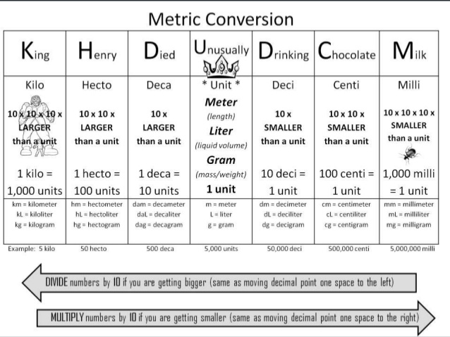
Electricity

$$Voltage=Current∙Resistance$$
$$V=IR$$

