Name____________________________________________

Forces and Motion Pre Lab

Joe needs to push a file cabinet across the room. He begins by just looking at it. (Scene 1)
He then begins pushing on the file cabinet. At first, the file cabinet does not move. (Scene 2) Then the file cabinet begins to slide. (Scene 3)

Scene 1:  Joe not pushing | Scene 2:  Joe pushing but cabinet not moving | Scene 3:  Joe pushing and cabinet moving
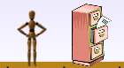 | 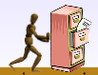 | 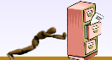

  - Use words and pictures to describe all the forces you think are acting on the cabinet in each scene.

  - Why do you think the file cabinet moves in scene 3 but not in scene 1 or 2?

  - If the floor is covered with ice, how would the motion of the cabinet change?

This page is blank

Name____________________________________________
Grade____________________________________________

Forces and Motion
Learning Objectives:
- Be able to identify when an object is being acted upon by unbalanced forces.
- Be able to predict the change in motion when a force is applied to an object.

Part 1: Understanding balanced and unbalanced forces

- Go to phet.colorado.edu and open the Forces and Motion Simulation under the Physics section of the simulations.

- Play with the first tab of the sim for about 5 minutes. What do you find?

- Using the simulation for help, draw pictures showing Joe, the file cabinet and force arrows.
Scene 1:  Joe not pushing | Scene 2:  Joe pushing but cabinet not moving | Scene 3:  Joe pushing and cabinet moving

- Describe what is necessary to start the file cabinet moving.

- Compare the Applied Force arrow and the Friction Force arrow.

  - What is similar?

  - What is different?

- Use your answers to #5 to say whether the forces are balanced or unbalanced in each scene.

Part 2: Understanding Applied, Friction and Total Force

- How can you make the Friction Force arrow longer?

- Apply enough force to move the cabinet.

  - What do you think happens to the Friction Force arrow when you stop applying force (no Applied Force arrow)?

  - What do you think happens to the Friction Force once the cabinet stops moving?

- How would you...

  - ...describe Friction Force?

  - ...describe Applied Force?

Teacher led discussion: Compare applied and friction forces.

- Have Joe move a new object. How is moving this object different from moving the file cabinet?

- In the table, draw the Total Force arrow for the different cases:
Scene 1:  Joe not pushing | Scene 2:  Joe pushing but dog not moving | Scene 3:  Joe pushing and dog moving
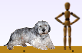 | 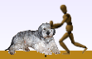

- Can you find 3 different ways to make the Total Force arrow change?
List them here:

- In your own words, what is Total Force?

- For each case, draw the Total Force arrow. Write which direction you think the object is moving and whether it will speed up or slow down.

  - 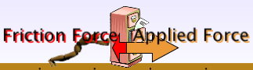

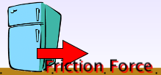

Part 3: Understanding Force and Change in Speed

- Give the sleepy dog a little push...

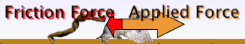
...how much does the dogs speed change?

- Give the sleepy dog a big push...

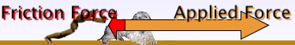
...how much does the dogs speed change?

- Using your answers to Question #15, what general statement can you make about the relationship between the applied force and how fast an object changes its speed.

Name____________________________________________
Grade____________________________________________

Forces and Motion Post Lab
Joe needs to push a file cabinet across the room. He begins by just looking at it. (Scene 1)
He then begins pushing on the file cabinet. At first, the file cabinet does not move. (Scene 2) Then the file cabinet begins to slide. (Scene 3)

Scene 1:  Joe not pushing | Scene 2:  Joe pushing but cabinet not moving | Scene 3:  Joe pushing and cabinet moving

- Use words and pictures to describe all the forces you think are acting on the cabinet in each scene.

- Why do you think the file cabinet moves in scene 3 but not in scene 1 or 2?

- What do you think Joe could do to make the cabinet move faster?

- If the floor is covered with ice, how would the motion of the cabinet change?
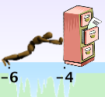

- What would be different if Joe was moving a book, instead of a file cabinet.
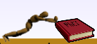

How useful for your learning was this science activity, compared to other science class activities? (circle)
More useful About the same Less useful
How enjoyable was this science class activity, compared to other science class activities? (circle)
More enjoyable About the same Less enjoyable
Why did you or did you not find it useful or enjoyable? ____________________________________________________________________________________________________________________________________________________________________________________________________________________________________________________________________________________________________________________

