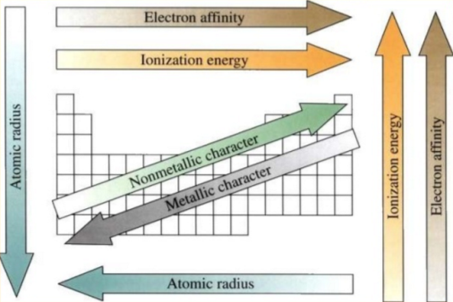
Exit Ticket – Name _________________________________
- What does periodic law say?

- Some of the trends are closely related and affect each other. Which ones do you think are related AND WHY???

Exit Ticket – Name _________________________________
- What does periodic law say?

- Some of the trends are closely related and affect each other. Which ones do you think are related AND WHY???

