GPS- Density

Name____________________________ Period__________
Bellwork
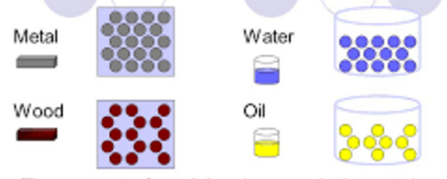
How would you compare the density of the two items below?

Introduction to Density
- Density __________________________________________________
- Formula for density
- Using the triangle
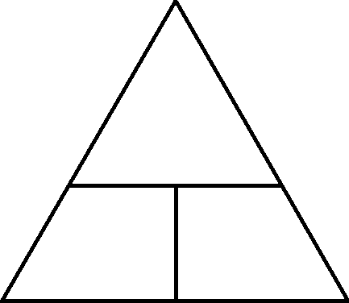 Cover the variable you want to find…
________________ if on top
________________ if side by side

Let’s Practice!! Complete “Density” Sheets on your own.

Density = Mass ÷ Volume 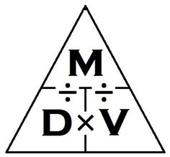 Units= g/cm³ or g/ml
Use the density formula to solve the following problems. Show all work and the answer must have the correct units. Mass is measured in grams or kilograms. Remember that volume can have different units. A block of ice with a volume of 3 cm³ would be 3 mL of liquid after being melted.

1. What is the density of CO gas if 0.196 g occupies a volume of 100 ml?

Answer_________________

2. A block of wood 3 cm on each side has a mass of 27 g. What is the density of the block? (Hint, don’t forget to find the volume of the wood. V=length x width x height)

Answer________________

3. An irregularly shaped stone has a volume of 7ml. If the mass of the stone was 25 g, what was its density?

Answer_______________
4. A 10.0 cm3 sample of copper has a mass of 89.6 g. What is the density of copper?

Answer_________

5. Silver has a density of 10.5 grams/cm³ and a volume of 5cm³. What is the mass of the sample? Use the triangle.

Answer_________

6. Ethanol has a volume of 5 mL and a mass of 3.9 g, and 5 mL of benzene has a mass of 44 g. Which liquid has a higher density? First, find the density of both. Then, circle the higher density.

Answer_________

7. A sample of iron has the same dimensions of 2 cm x 3 cm x 2 cm. If the mass of this rectangular-shaped object is 94 g, what is the density of iron? First, find the volume (length x width x height).

Answer_________

Raise your hand when you’re done to get Ms. Crowley or Ms. Perry’s initials in the box!
Teacher’s Initials

