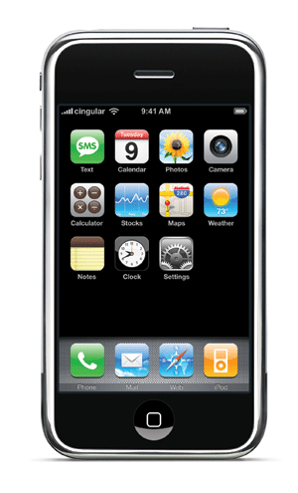

**Classroom Cell Phone Acceptable Use Policy**

**Student’s Name: ______________________________**

1. Students will only use their cell phone to complete assignments that are related to the instructional lesson with teacher permission.
2. During other class periods, students will follow the building policy for cell phone use.
3. Students will not send text messages or make calls to others outside of class.
4. Students will not record any image, video, or audio of other students, the teacher, or materials without permission.
5. Students will not post any recordings or images to online websites without permission.
6. Students will practice internet safety with online resources.
7. Students will only send and post appropriate and authorized text, audio, and visual media only to websites approved by Shaker Heights School District.
8. Students understand that if their use of their cell phone during class time violates the agreement, it will be withheld for the class period and other action may be taken.

**Student Statement of Agreement:**

I understand that violation of our Classroom Cell phone Acceptable Use Policy may result in my not being able to participate in additional class activities that involve a cell phone. I also understand that I will be held accountable for actions according to the disciplinary guidelines I signed at the beginning of the school year.

Signature___________________________________________________________________