Atom – Preassessment
Name:_____________________________________________________
Define the following terms with NO resources the BEST you can! Don’t leave blanks!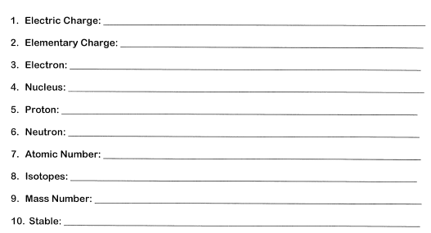

Atom – Preassessment
Name:_____________________________________________________
Define the following terms with NO resources the BEST you can! Don’t leave blanks!

