Sour taste | Not reactive with metals | 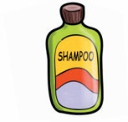  Shampoo
H⁺ ions | Conducts electricity | 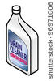  Drain cleaner
Fruits and juices | Cleaning products | 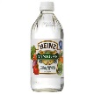  Vinegar
Feels slippery | pH less than 7 | 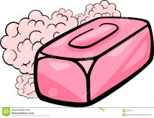  Soap
Corrosive | pH greater than 7 | 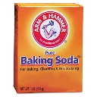  Baking soda
OH⁻ ions | Blue litmus paper turns red | 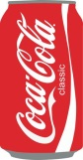  Soda
Bitter taste | Red litmus turns blue | 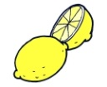  Lemon
Reactive with metals | Has no distinct feel | 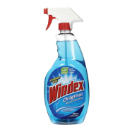  Ammonia window cleaner

Acids + Bases Matching
- In pairs, color the boxes provided that describe the properties of acids red.
- Color the boxes provided that describe the properties of bases blue.
- Then, cut out the boxes and sort them on the Venn diagram.
- When you are done, let Ms. Perry know. She will take a picture of your Venn diagram.
- After your Venn diagram is complete, answer the questions below with your partner.

Questions:
Names: ________________________ & ____________________________

- Explain the 3 parts of the pH scale (below 7, exactly 7, above 7).
- Why is a substance at 0 or at 14 on the pH scale considered dangerous?
- Why would you want your drinking water to be exactly or close to a pH of 7?

