Acid & Base Properties

Name _____________________ Period _________________

- All acids release what ion when they’re in a water solution?

- All bases release what ion when they’re in a water solution?

- List these compounds in the correct rows…

H2SO4 Ba(OH)2 KOH H3PO4 HF NaOH H2O

acids bases

- Tell what the properties of acids and bases are in terms of…

reacting with a metal
acids bases

feeling in solution
acids bases

taste (if safe to do so)
acids bases

pH range
acids bases

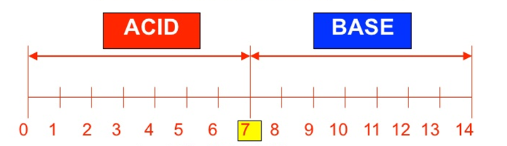
- Identify if the following is an acid or a base given the pH information.

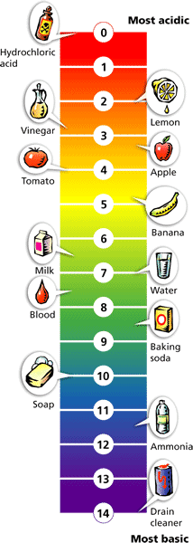
- Tap water = pH of 6.8 ______________
- Some people’s saliva = pH of 5.6 ______________
- Baking soda = pH of 8.2 ______________
- Stomach acid = pH of 2.9 ______________
- Milk of magnesia = pH of 10.5 ______________
- Ammonia = pH of 12.1 ______________
- Vinegar = pH of 3.0 ______________
- Milk = pH of 6.9 ______________
- Coca-cola = pH of 2.5 ______________

